# Spring vs J2EE Release Notes

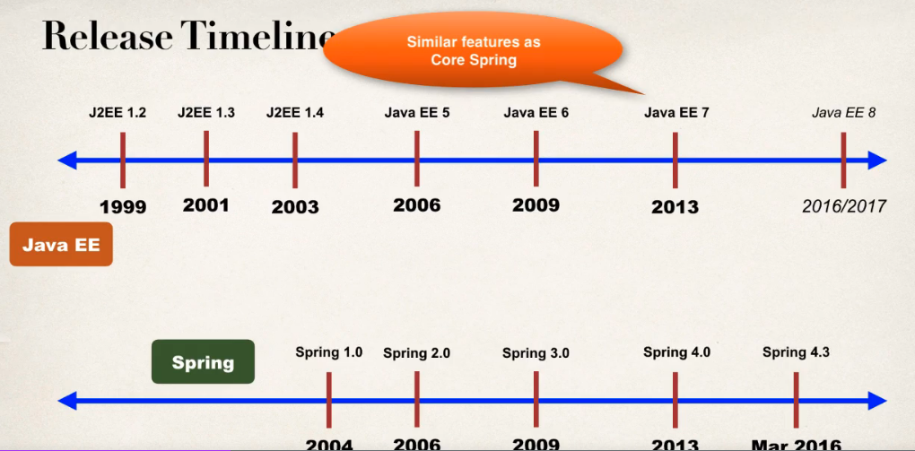

## Spring 5 updates

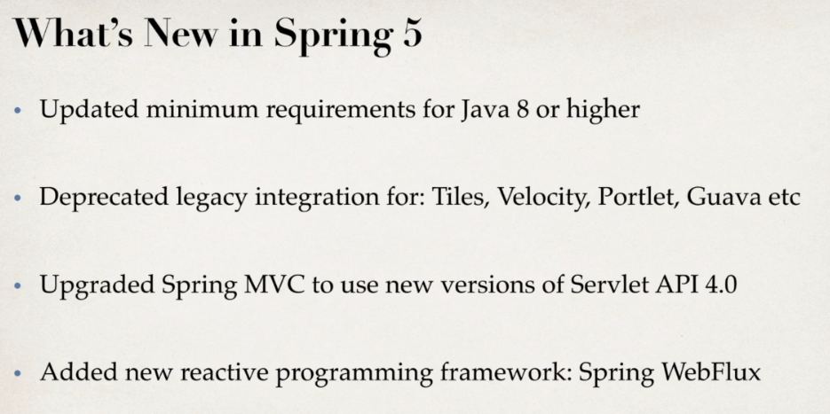

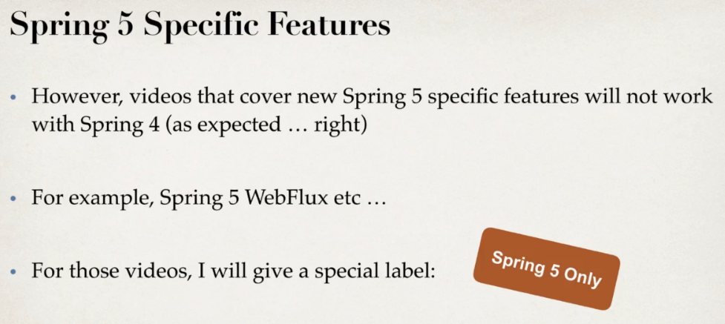

## Goals of Spring

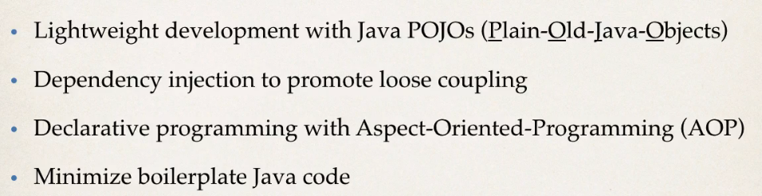

## Spring Projects

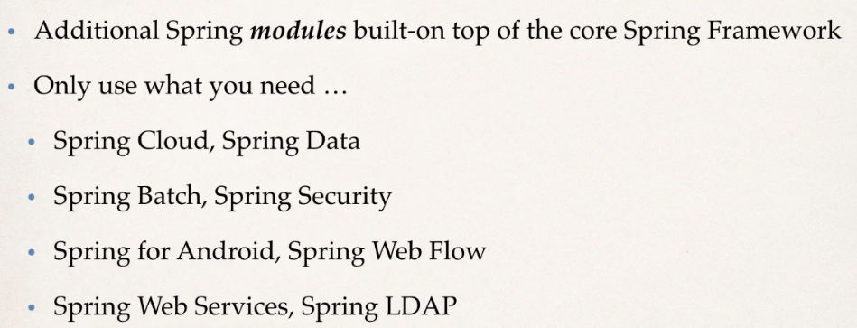

# Spring IoC

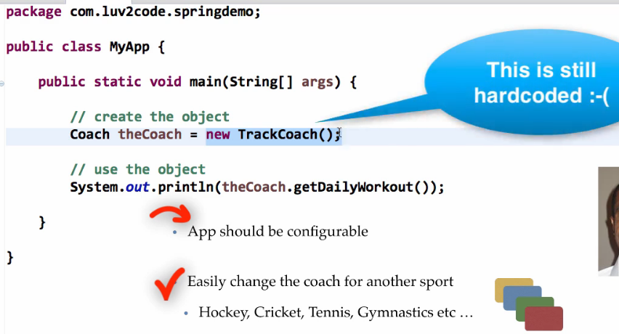

For configurable spring solves it.

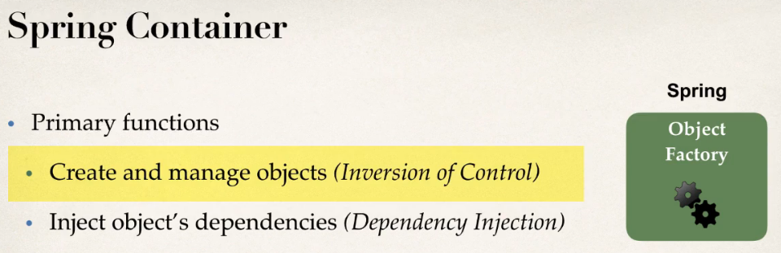

## 3 ways of configuring Spring Container

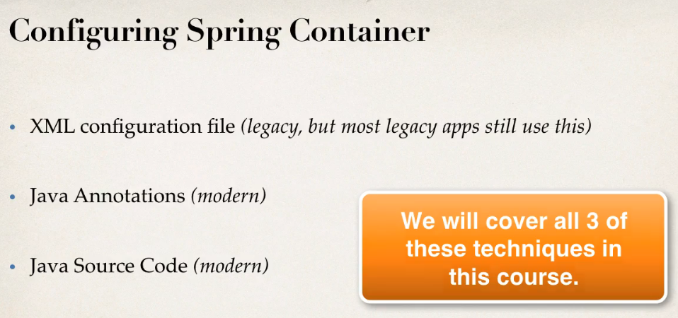

## XML Configuration

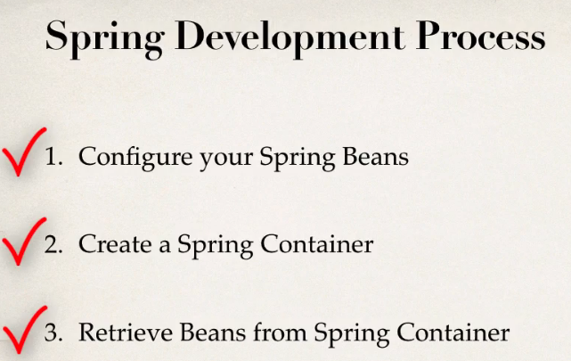

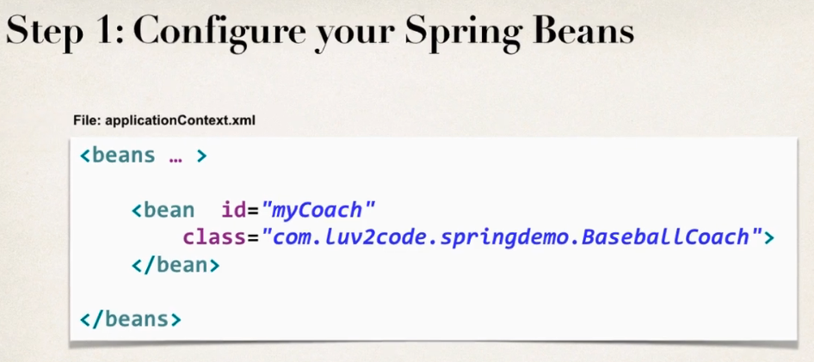

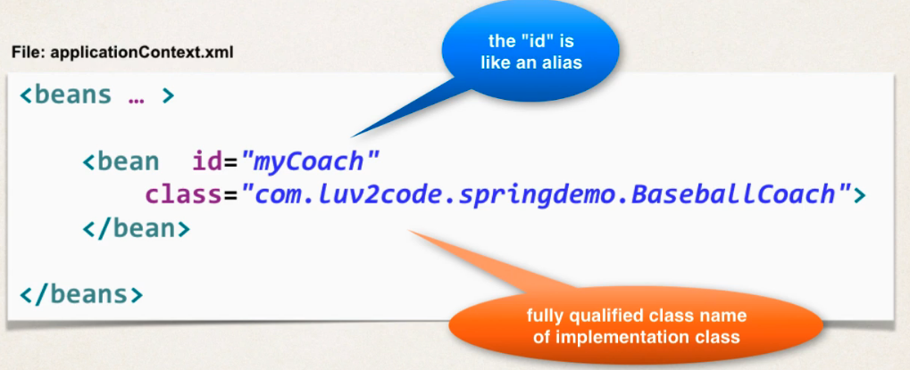

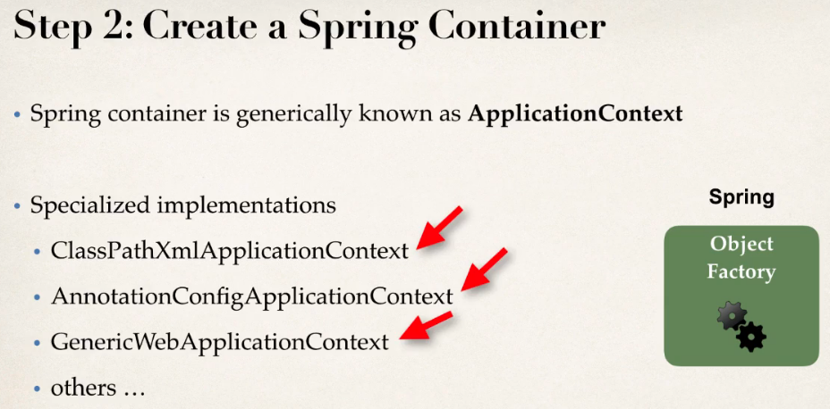

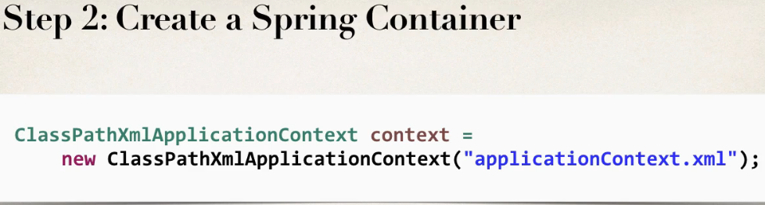

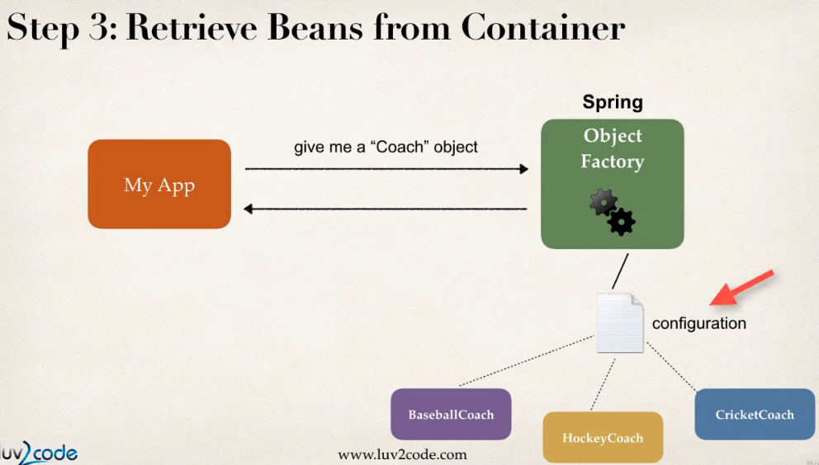

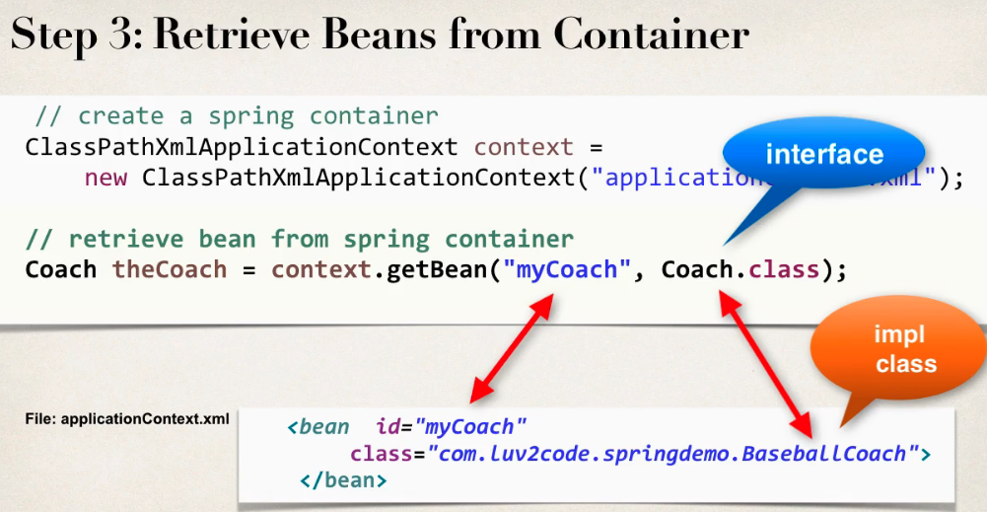

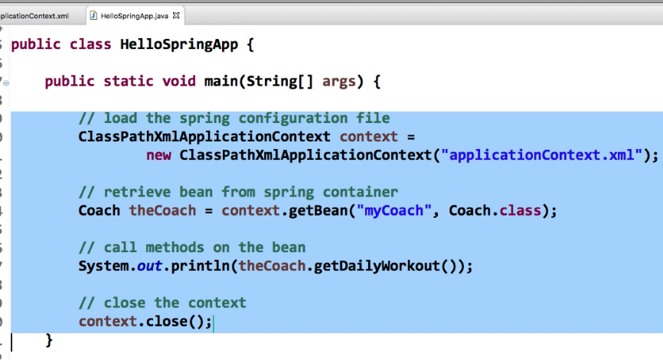

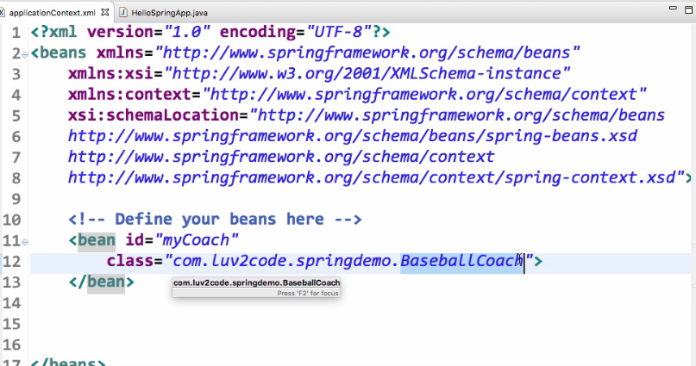



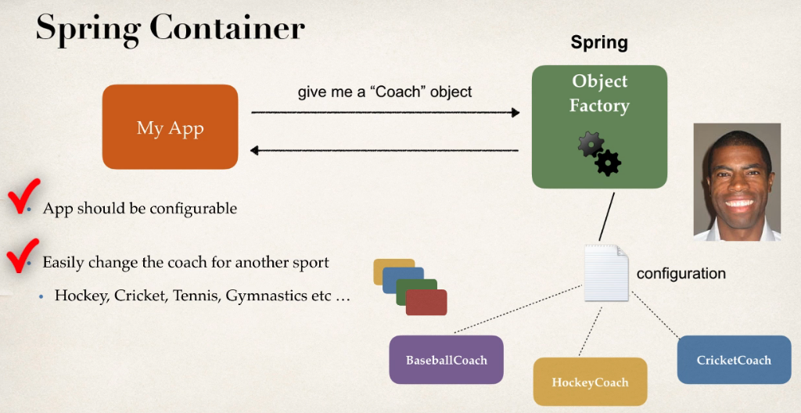

**FAQ: What is a Spring Bean?**

A "Spring Bean" is simply a Java object.

When Java objects are created by the Spring Container, then Spring refers to them as "Spring Beans".

Spring Beans are created from normal Java classes .... just like Java objects.

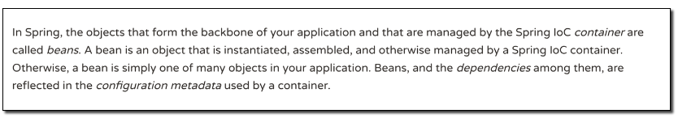

Important link—Need to visit

<https://docs.spring.io/spring/docs/current/spring-framework-reference/core.html#beans-introduction>

In the early days, there was a term called "Java Beans". Spring Beans have a similar concept but Spring Beans do not follow all of the rigorous requirements of Java Beans.

**Question**

Why do we specify the Coach interface in getBean()?

For example:

Coach theCoach = context.getBean("myCoach", Coach.class);

---

**Answer**

When we pass the interface to the method, behind the scenes Spring will cast the object for you.

context.getBean("myCoach", Coach.class)

However, there are some slight differences than normal casting.

From the Spring docs:

Behaves the same as getBean(String), but provides a measure of type safety by throwing a BeanNotOfRequiredTypeException if the bean is not of the required type. This means that ClassCastException can't be thrown on casting the result correctly, as can happen with getBean(String).

Source:  <http://docs.spring.io/spring-framework/docs/current/javadoc-api/org/springframework/beans/factory/BeanFactory.html#getBean-java.lang.String-java.lang.Class->

## Spring DI

Here we get object that is ready to use

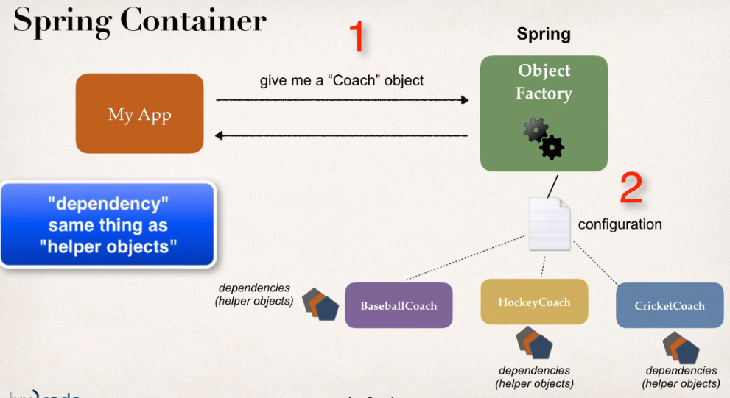

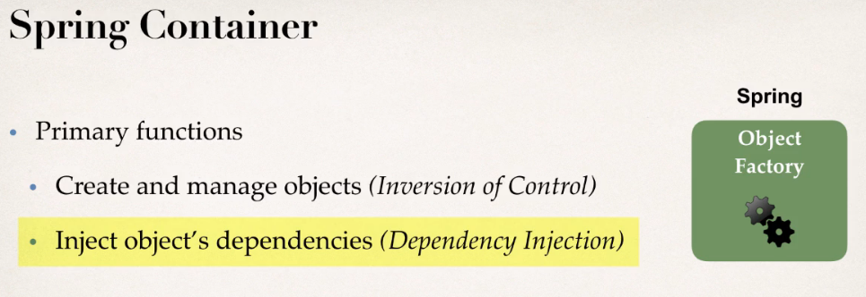

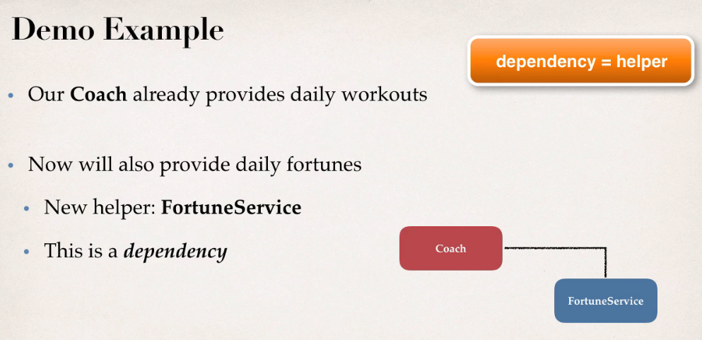

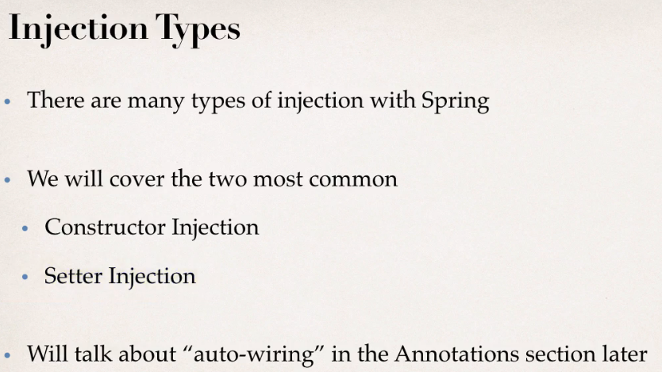

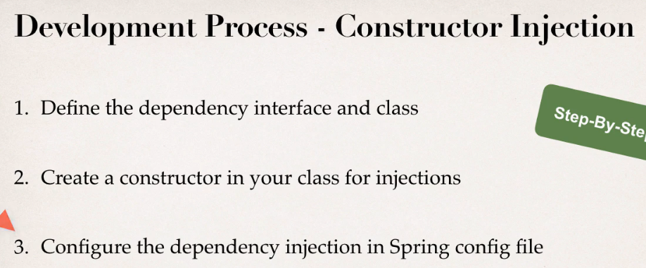

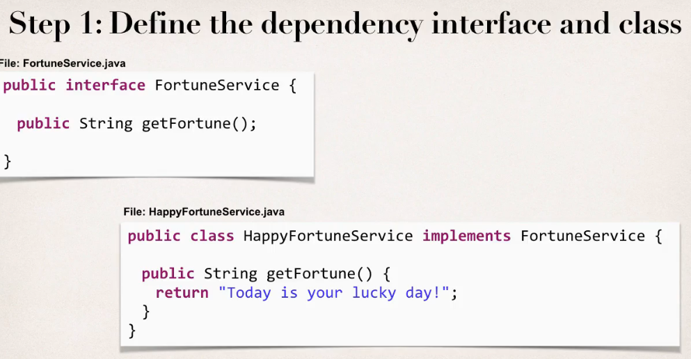

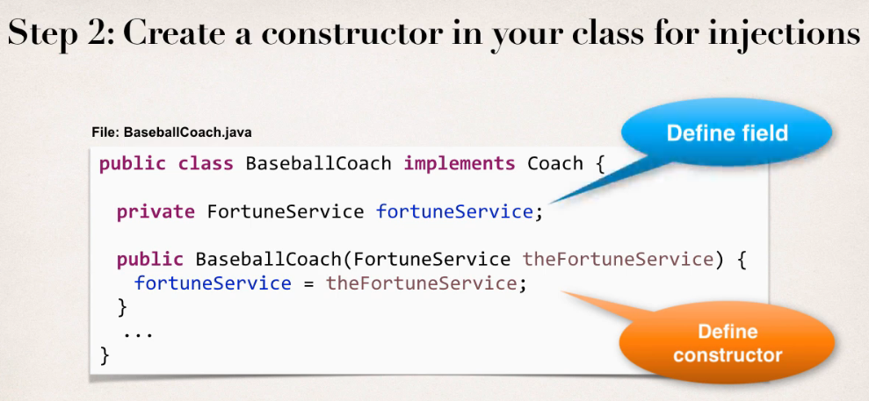

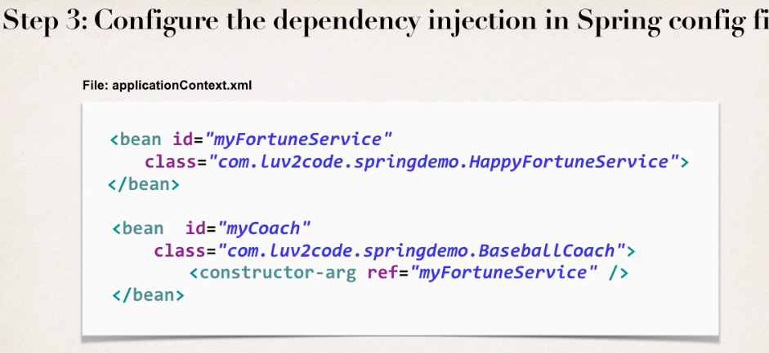

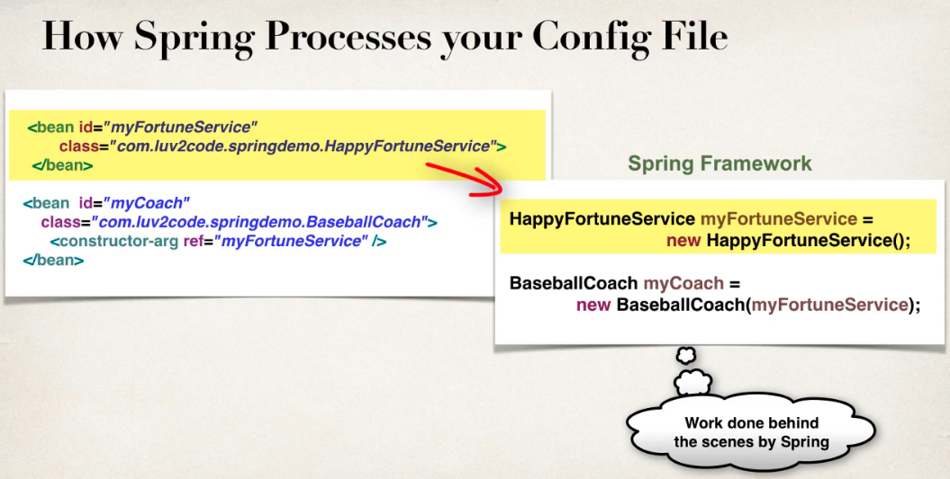

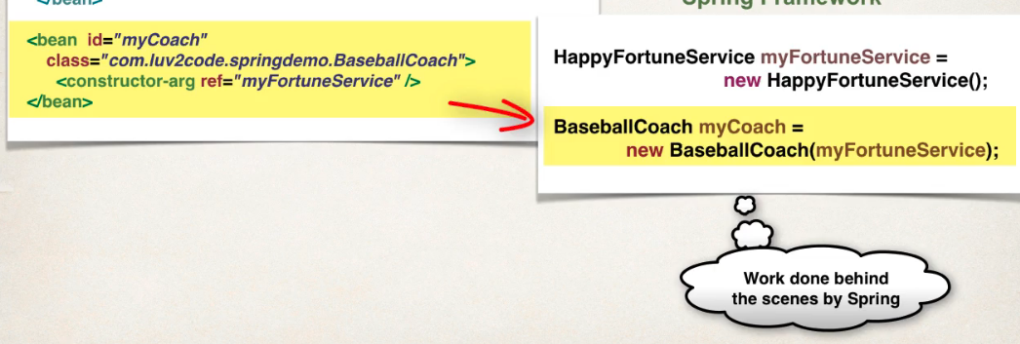

Spring will do this behind the scenes

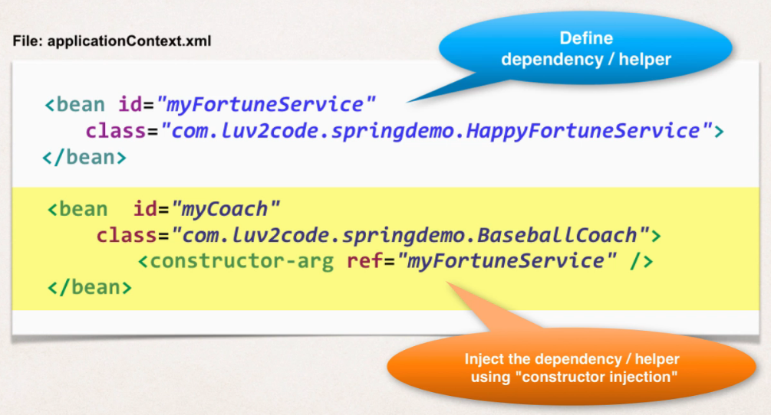

### Setter Injection

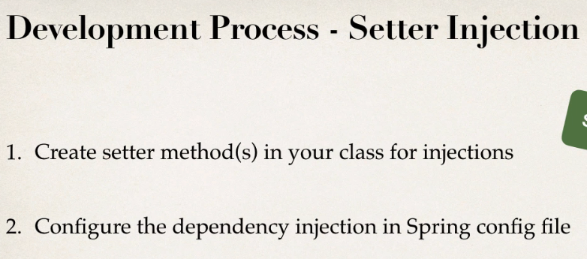

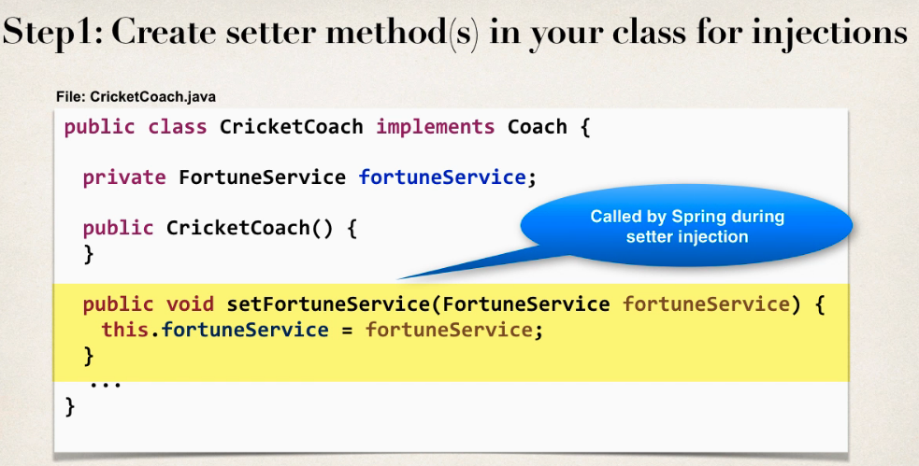

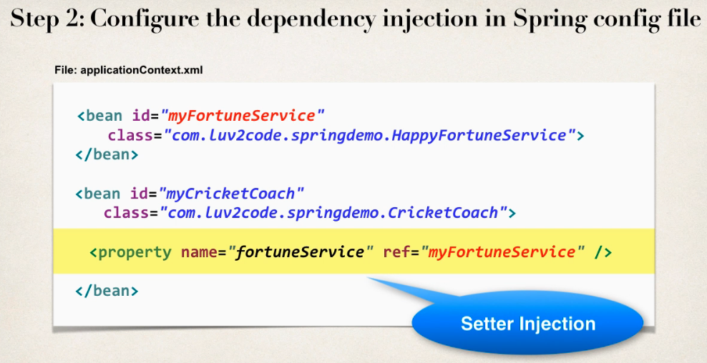

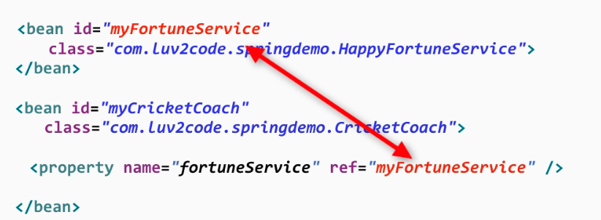

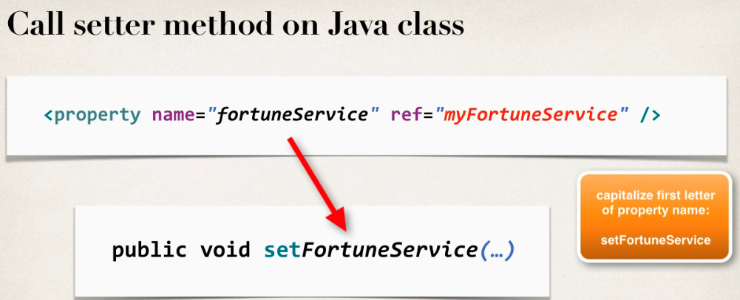

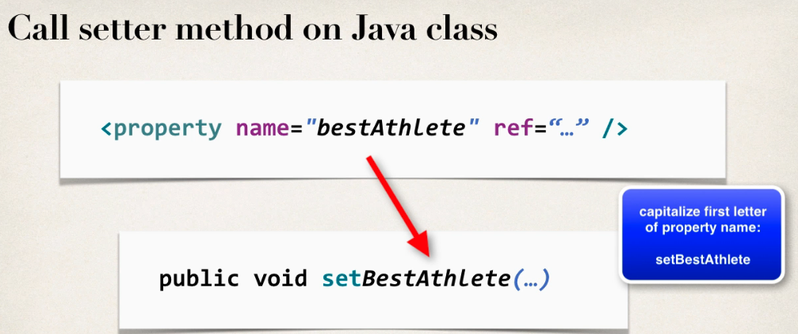

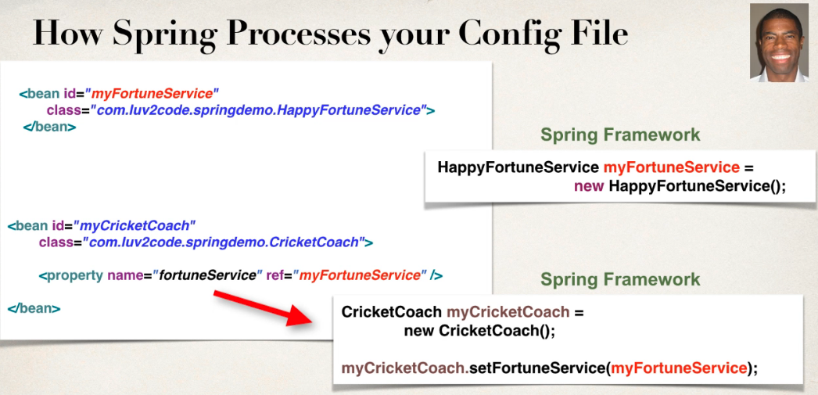

## Spring configuration with Annotations

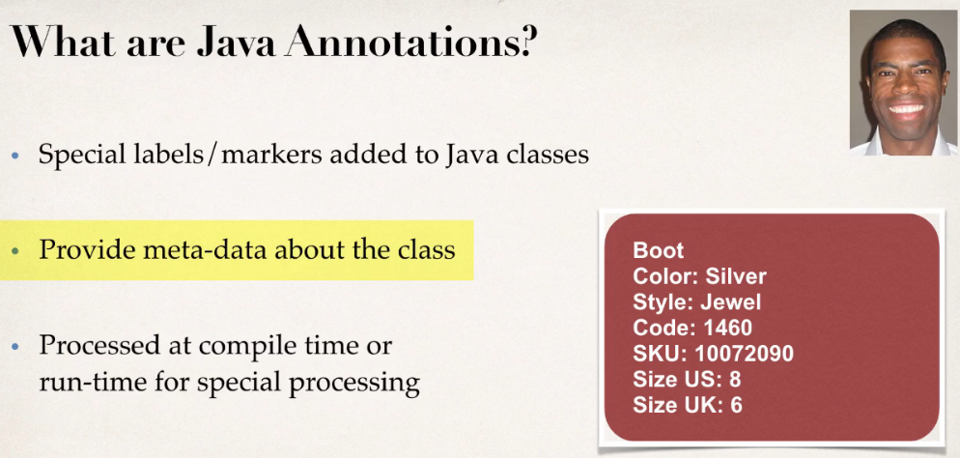

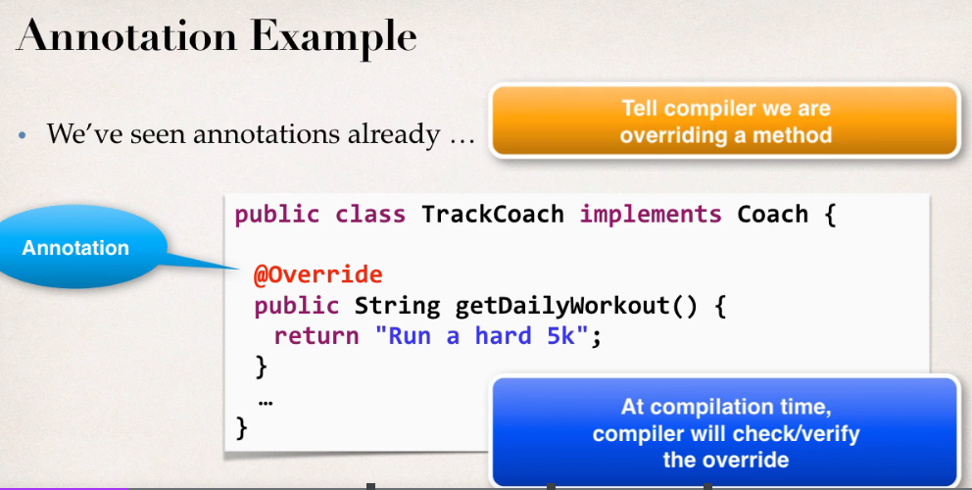

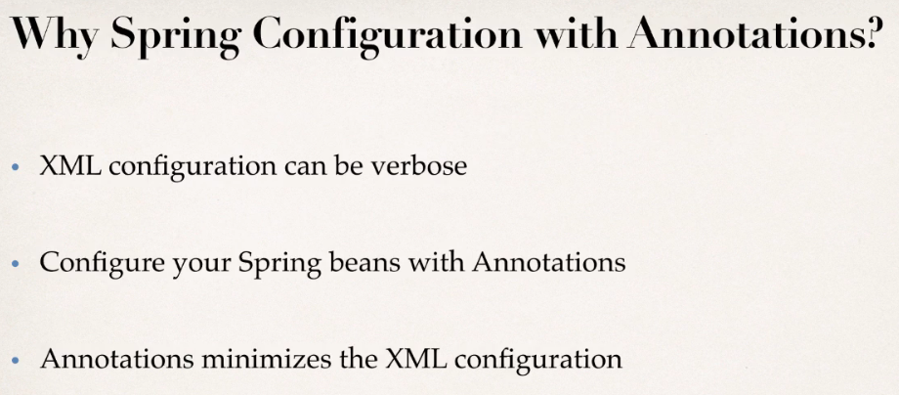

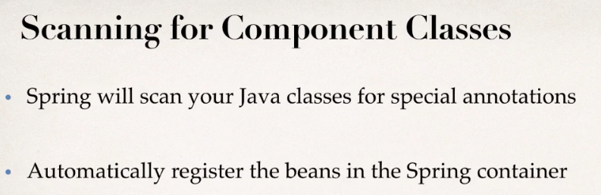

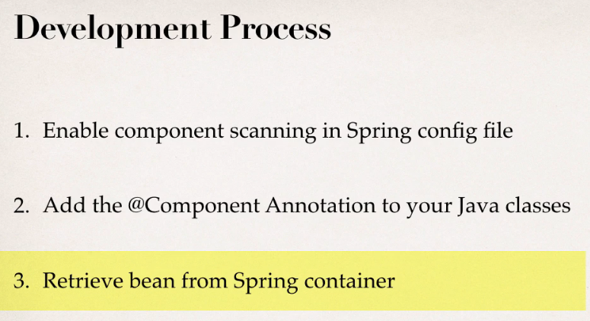

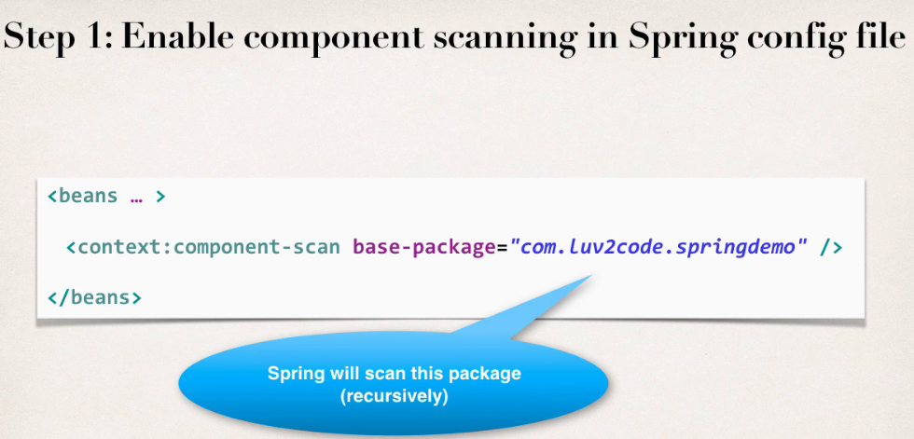

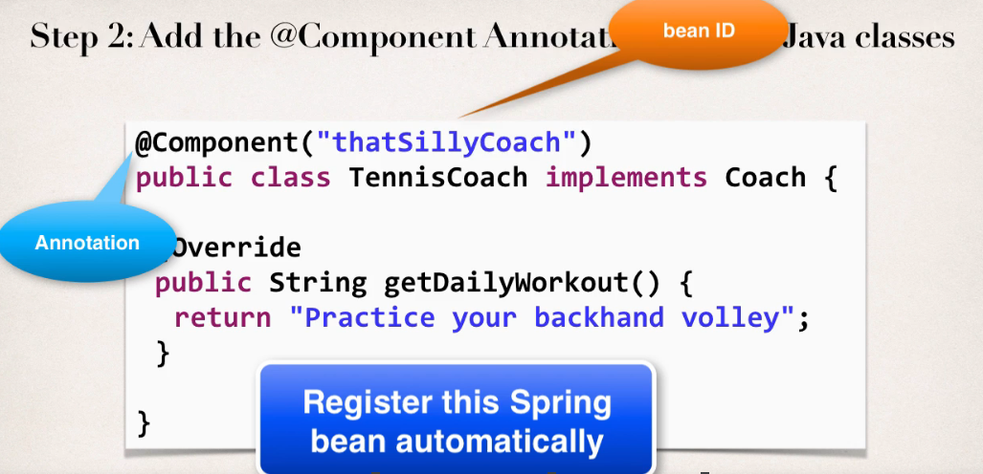

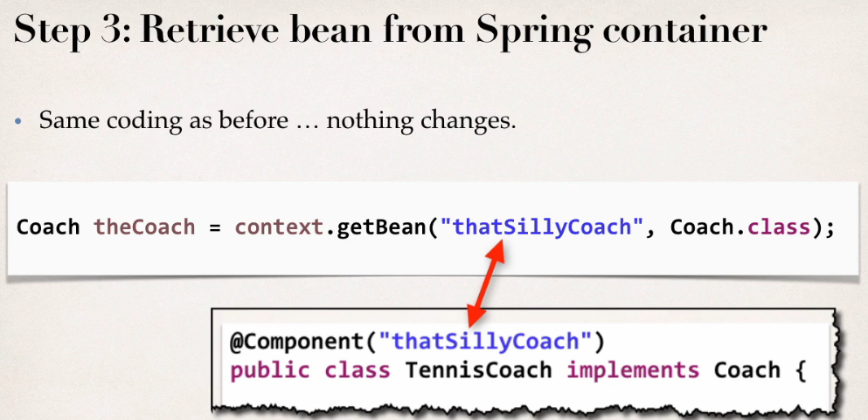

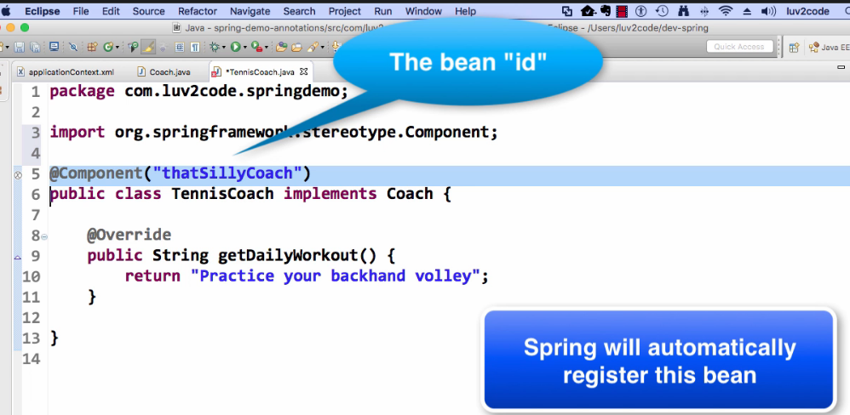

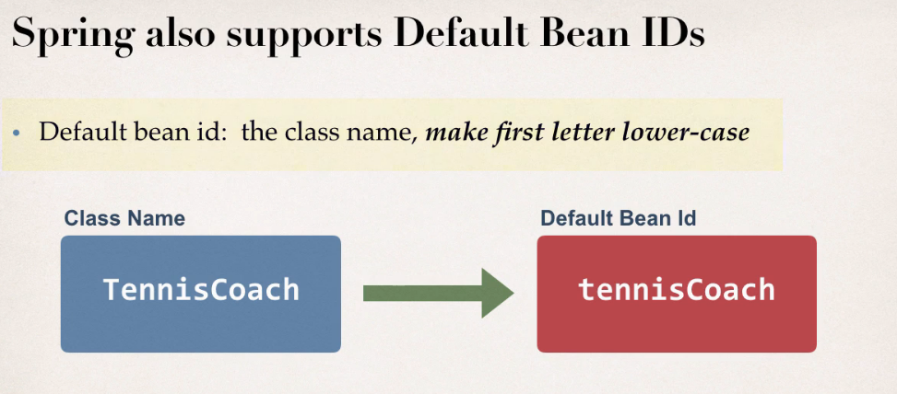

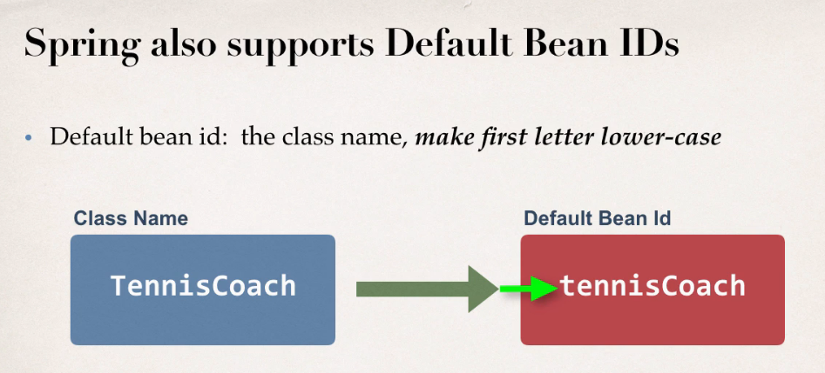

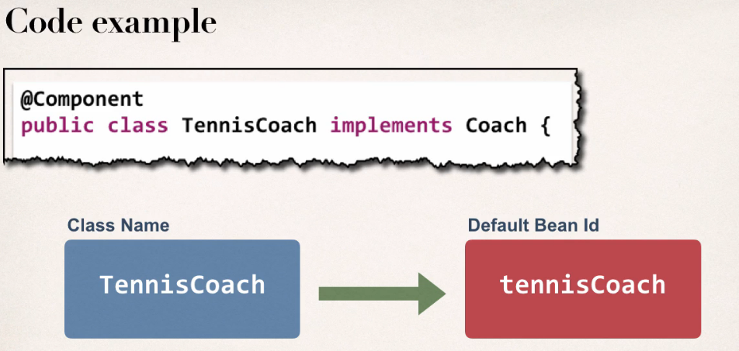

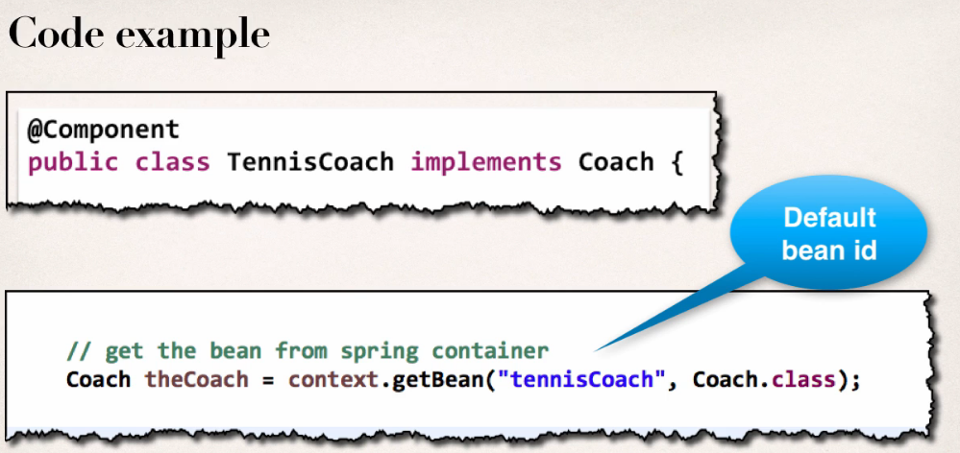

## DI with Annotations and autowiring

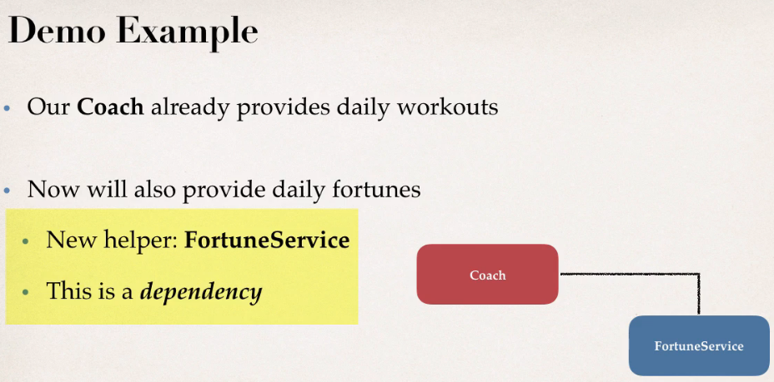

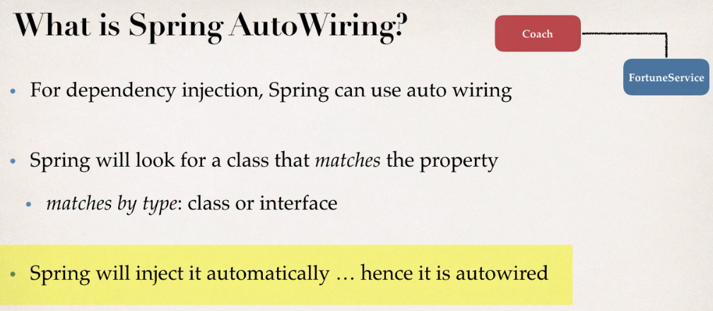

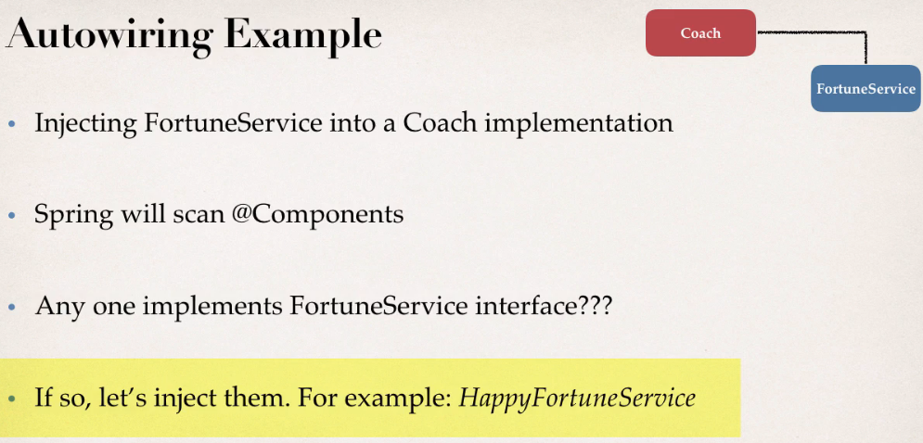

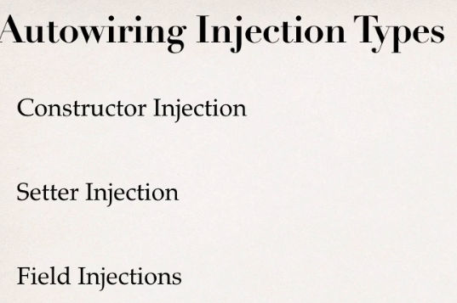

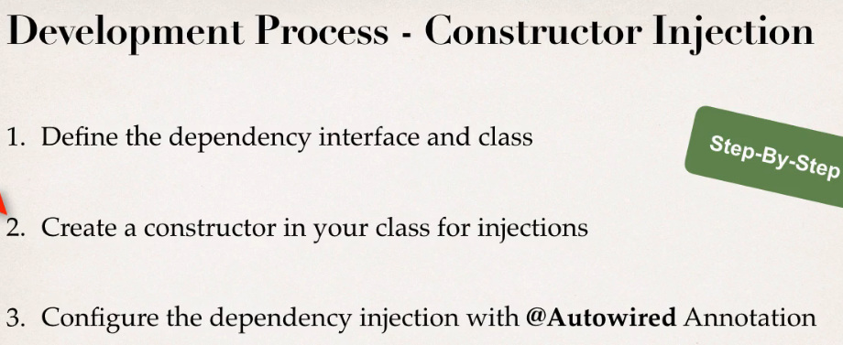

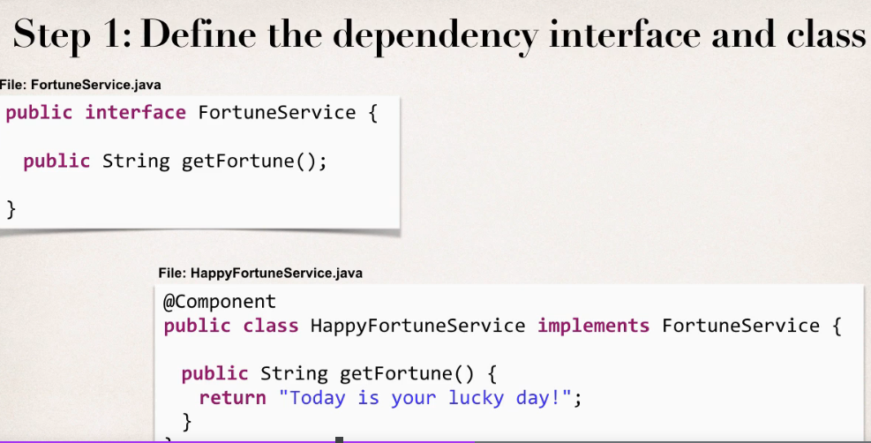



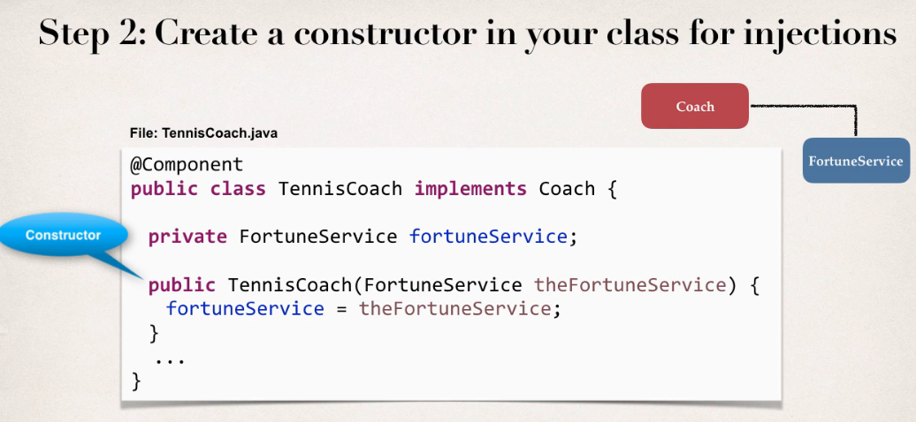

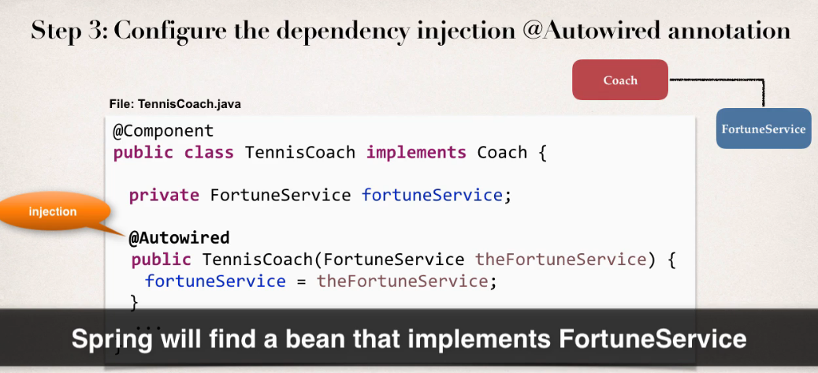

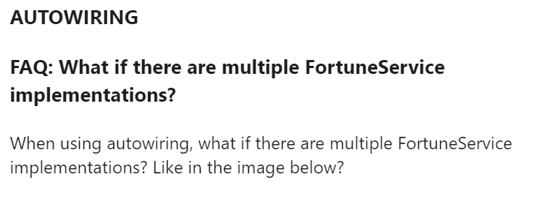

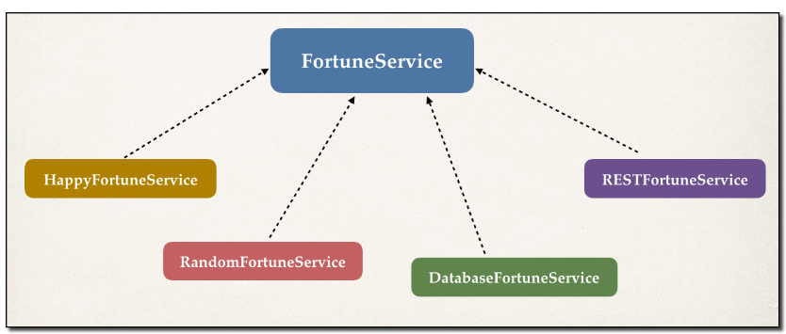

**ANSWER**

Spring has special support to handle this case. Use the **@Qualifier** annotation. We'll cover this later in the course with slides and code examples. But don't worry, we will address all scenarios :-)

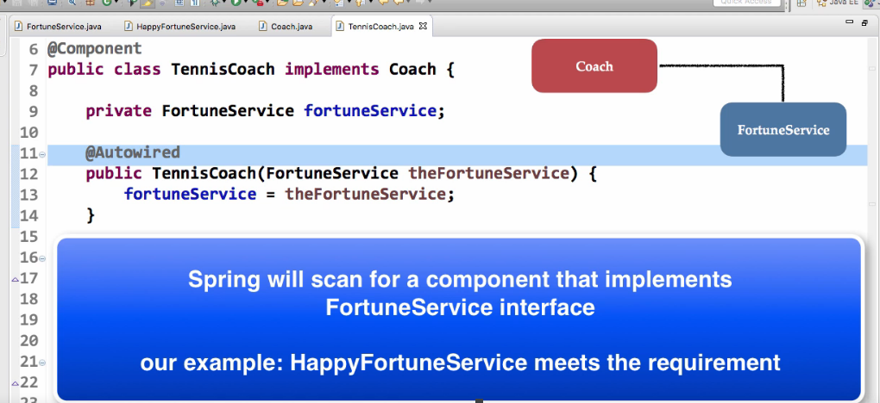

Constructor Injection - Autowired Optional?

**Answer**

This is a new feature of Spring 4.3.

Here is the snippet from the Spring Docs.

**Section 1.9.2: Autowired**

As of Spring Framework 4.3, an *@Autowired* annotation on such a constructor is no longer necessary if the target bean only defines one constructor to begin with. However, if several constructors are available, at least one must be annotated to teach the container which one to use.

I personally prefer to use the @Autowired annotation because it makes the code more readable. But as mentioned, the @Autowired is not required for this scenario.

---

See link to the docs.

<https://docs.spring.io/spring/docs/current/spring-framework-reference/core.html#beans-autowired-annotation>

<https://docs.spring.io/spring-framework/docs/current/reference/html/core.html#beans-autowired-annotation>

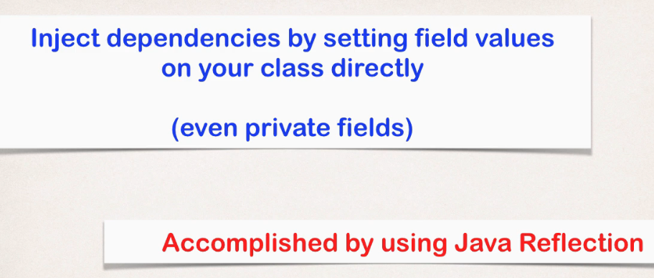

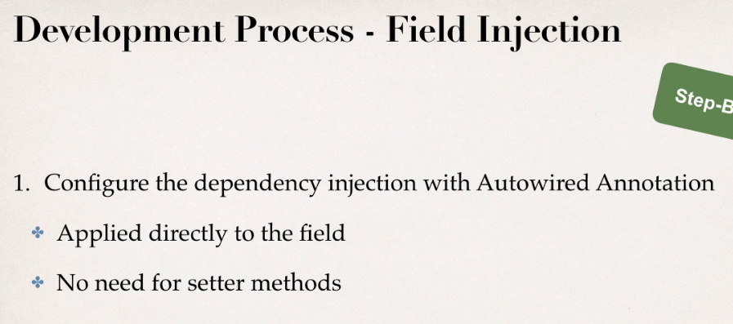

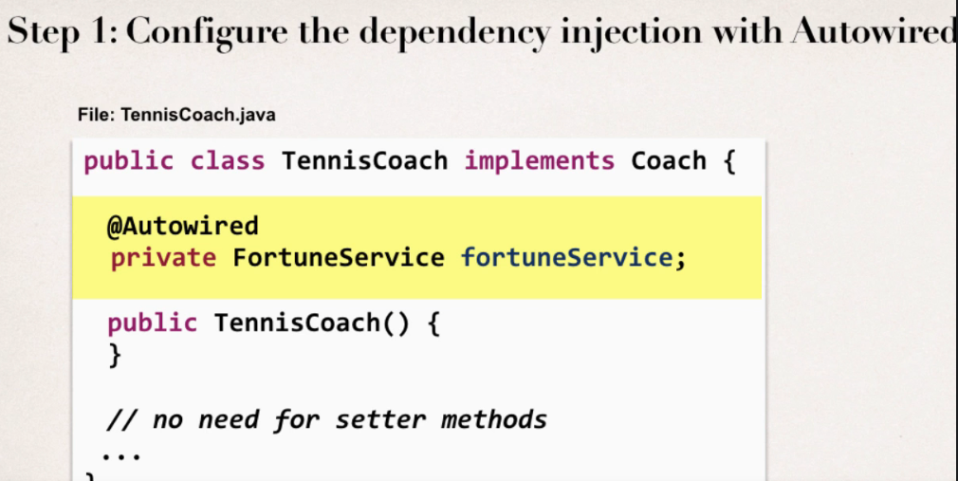

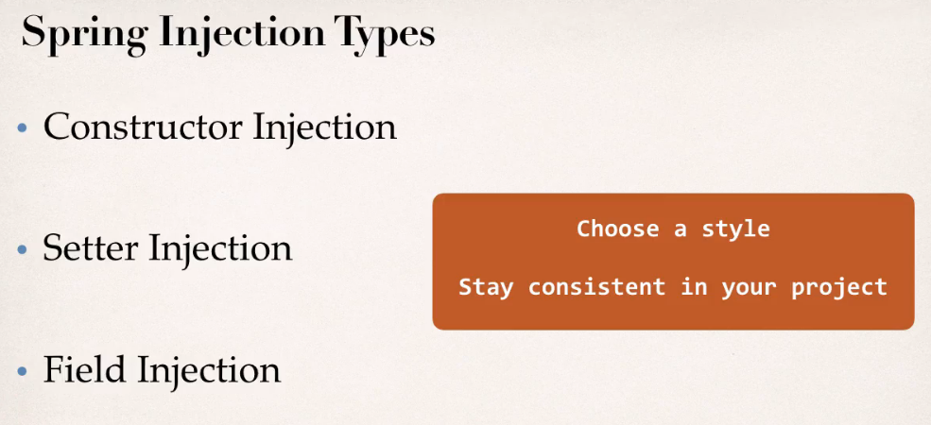

## Qualifiers for DI

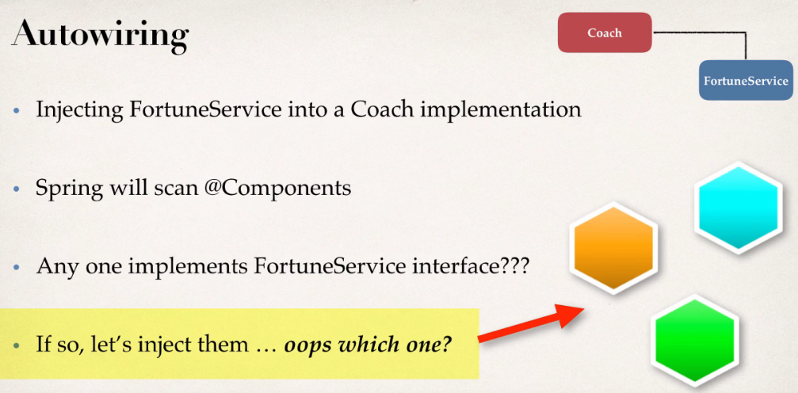

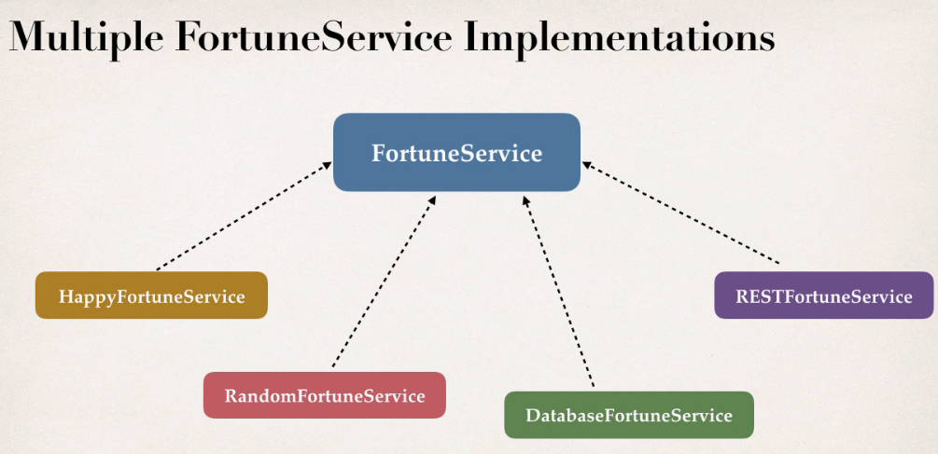

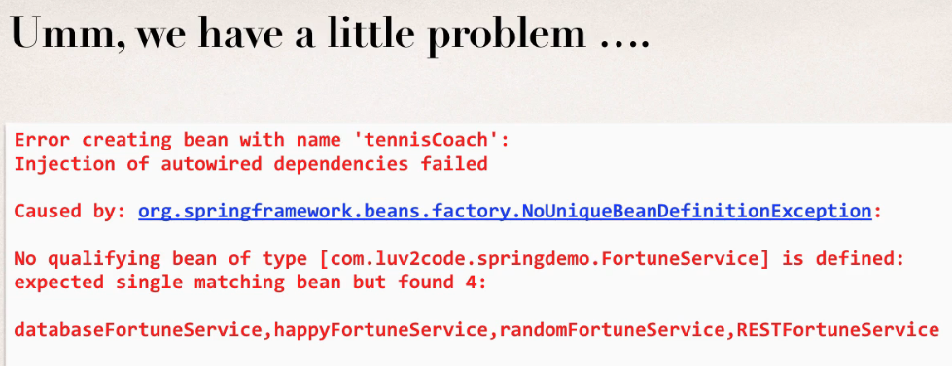

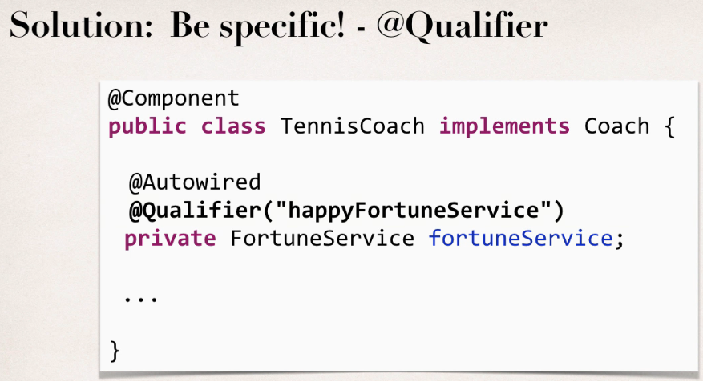

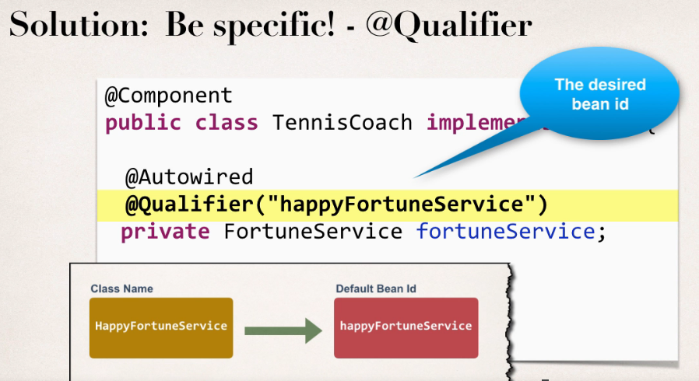

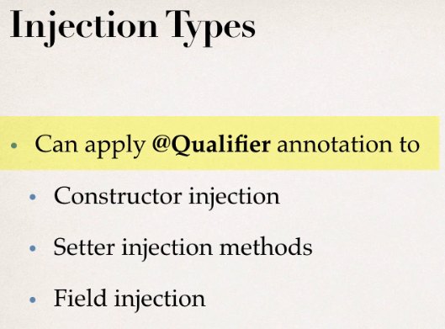

<https://docs.oracle.com/javase/8/docs/api/java/beans/Introspector.html#decapitalize(java.lang.String)>

### Qualifier with constructor injection

**@Qualifier** is a nice feature, **but it is tricky when used with Constructors**.

The syntax is much different from other examples and not exactly intuitive.

Consider this the "deep end of the pool" when it comes to Spring configuration LOL :-)

You have to place the @Qualifier annotation inside of the constructor arguments.

Here's an example from our classroom example.

with @Autowired and @Qualifier. Make note of the code in bold below:

---  
package com.luv2code.springdemo;

import org.springframework.beans.factory.annotation.Autowired;

import org.springframework.beans.factory.annotation.Qualifier;  
import org.springframework.stereotype.Component;

@Component  
public class TennisCoach implements Coach {

   private FortuneService fortuneService;

    // define a default constructor  
    public TennisCoach() {  
        System.out.println(">> TennisCoach: inside default constructor");  
    }  
      
**@Autowired  
    public TennisCoach(@Qualifier("randomFortuneService") FortuneService theFortuneService) {**

**System.out.println(">> TennisCoach: inside constructor using @autowired and @qualifier");  
          
        fortuneService = theFortuneService;  
    }**         
      
    /*  
    @Autowired  
    public void doSomeCrazyStuff(FortuneService theFortuneService) {  
        System.out.println(">> TennisCoach: inside doSomeCrazyStuff() method");  
        fortuneService = theFortuneService;  
    }  
    */  
      
    /*  
    @Autowired  
    public TennisCoach(FortuneService theFortuneService) {  
        fortuneService = theFortuneService;  
    }  
    */  
      
    @Override  
    public String getDailyWorkout() {  
        return "Practice your backhand volley";  
    }

    @Override  
    public String getDailyFortune() {  
        return fortuneService.getFortune();  
    }

}

---

For detailed documentation on using @Qualifier with Constructors, see this link in the Spring Reference Manual

<https://docs.spring.io/spring/docs/current/spring-framework-reference/core.html#beans-autowired-annotation-qualifiers>

 ====

**@Qualifier with Setter Injection**

You can use similar syntax with Setter Injection. You can use @Qualifier in method arguments line, such as

1. @Autowired
2. public void setFortuneService(@Qualifier("randomFortuneService") FortuneService theFortuneService) {
3. System.out.println(">> TennisCoach: inside setFortuneService() method");
4. this.fortuneService = theFortuneService;
5. }

You can also use the @Qualifier above the method name. For example, here's the syntax

1. @Autowired
2. @Qualifier("randomFortuneService")
3. public void setFortuneService(FortuneService theFortuneService) {
4. System.out.println(">> TennisCoach: inside setFortuneService() method");
5. this.fortuneService = theFortuneService;
6. }

**FAQ: How to inject properties file using Java annotations**

**Answer:**

This solution will show you how inject values from a properties file using annotatons. The values will no longer be hard coded in the Java code.

**1. Create a properties file to hold your properties. It will be a name value pair.**

New text file:  src/sport.properties

1. foo.email=myeasycoach@luv2code.com
2. foo.team=Silly Java Coders

Note the location of the properties file is very important. It must be stored in src/sport.properties

**2. Load the properties file in the XML config file.**

File: applicationContext.xml

Add the following lines:

    <context:property-placeholder location="classpath:sport.properties"/>

This should appear just after the <context:component-scan .../> line

**3. Inject the properties values into your Swim Coach: SwimCoach.java**

1. @Value("${foo.email}")
2. private String email;
4. @Value("${foo.team}")
5. private String team;

---

**DOWNLOAD FULL SOURCE CODE**

You can download entire code from here:

- <http://www.luv2code.com/downloads/spring-hibernate/spring-props-annotation-demo.zip>

## How to inject properties file using java annotations

FAQ: How to inject properties file using Java annotations

**Answer:**

This solution will show you how inject values from a properties file using annotatons. The values will no longer be hard coded in the Java code.

**1. Create a properties file to hold your properties. It will be a name value pair.**

New text file:  src/sport.properties

1. foo.email=myeasycoach@luv2code.com
2. foo.team=Silly Java Coders

Note the location of the properties file is very important. It must be stored in src/sport.properties

**2. Load the properties file in the XML config file.**

File: applicationContext.xml

Add the following lines:

    <context:property-placeholder location="classpath:sport.properties"/>

This should appear just after the <context:component-scan .../> line

**3. Inject the properties values into your Swim Coach: SwimCoach.java**

1. @Value("${foo.email}")
2. private String email;
4. @Value("${foo.team}")
5. private String team;

---

<http://www.luv2code.com/downloads/spring-hibernate/spring-props-annotation-demo.zip>

## Bean scope with Annotations

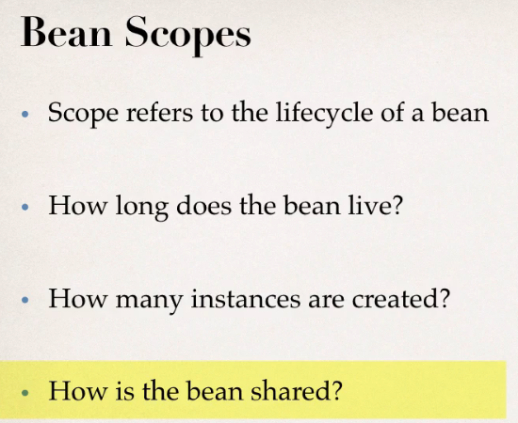

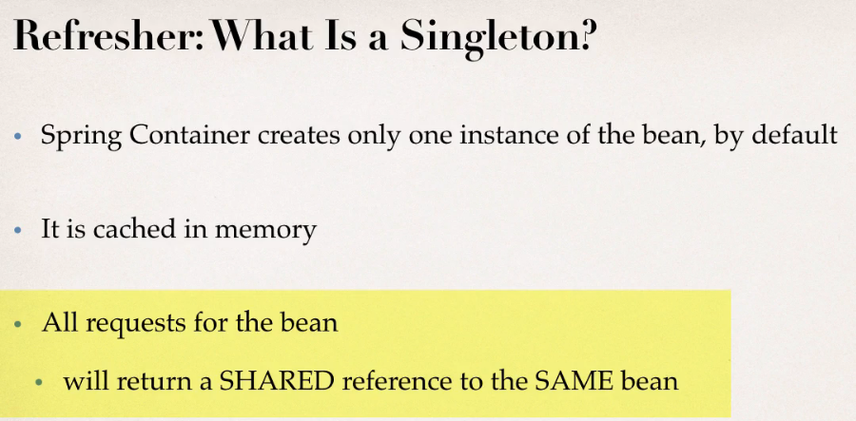

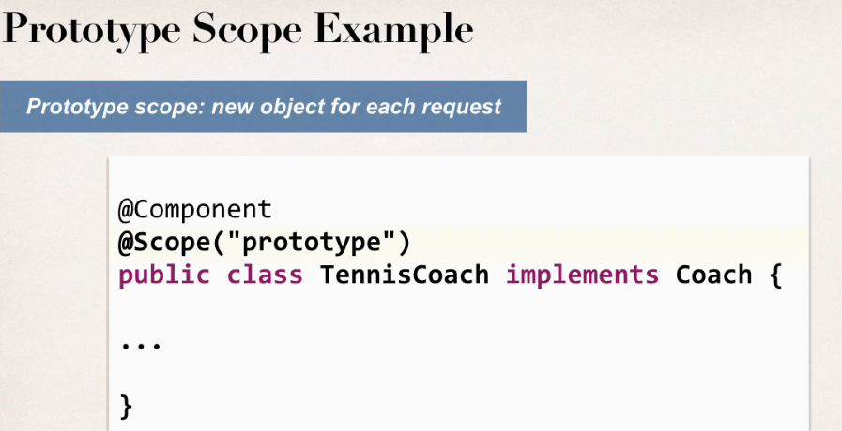

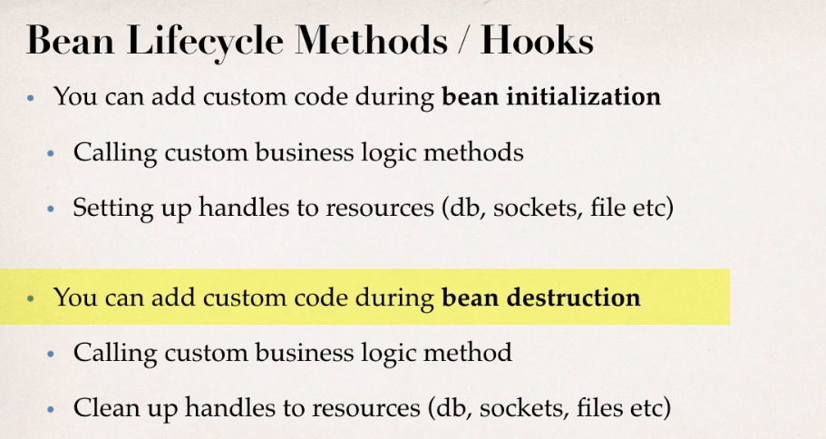

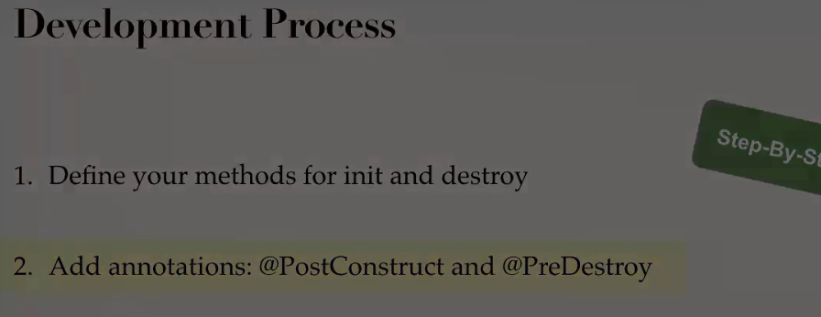

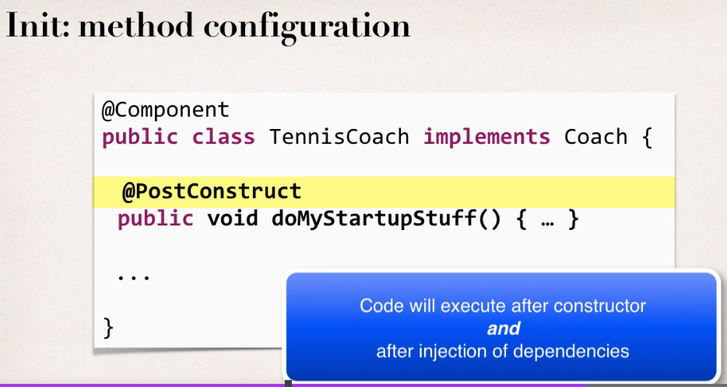

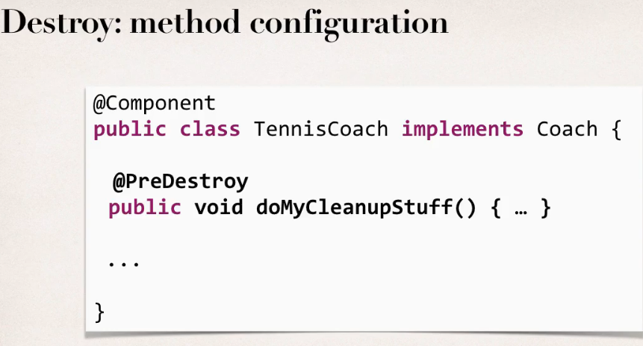

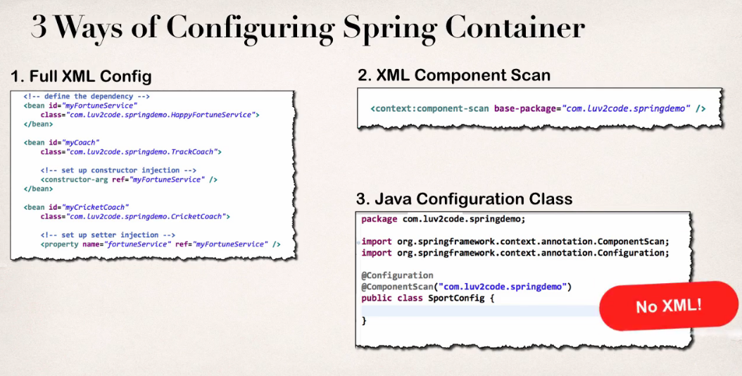

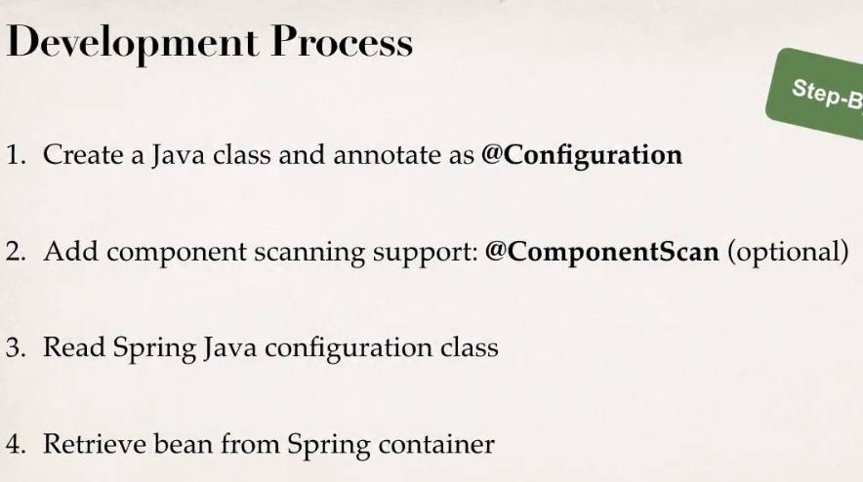

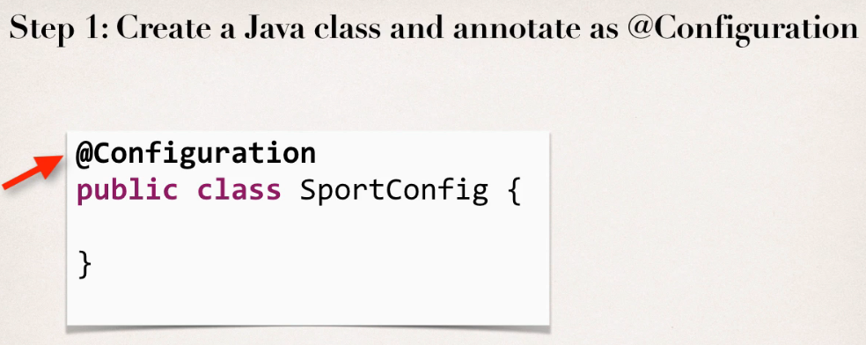

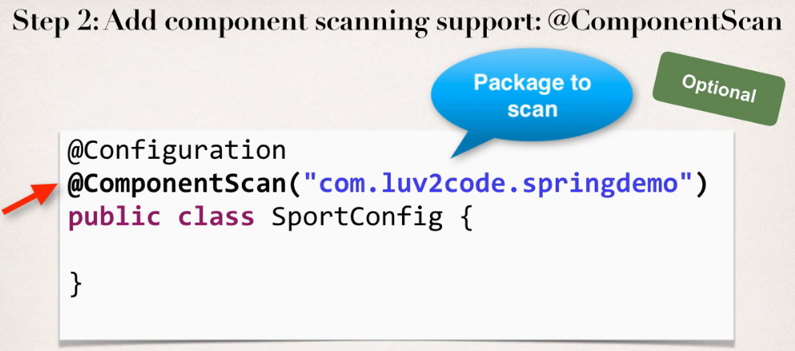

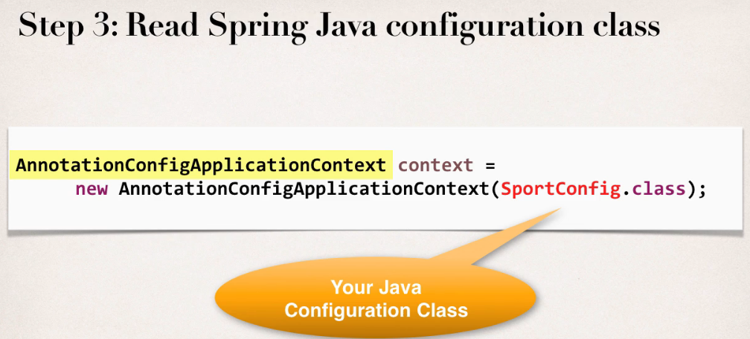

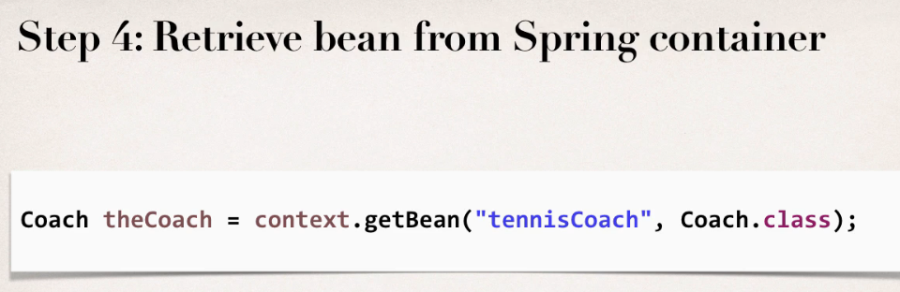

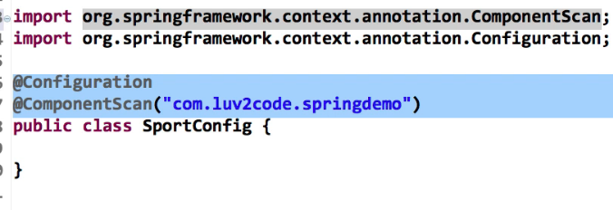

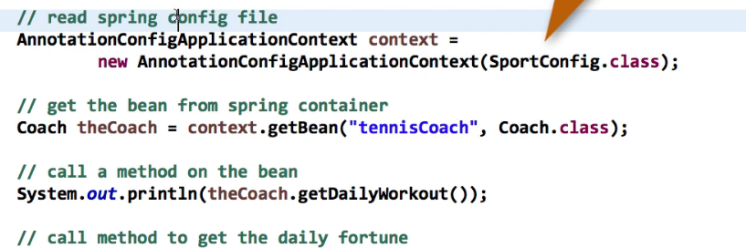

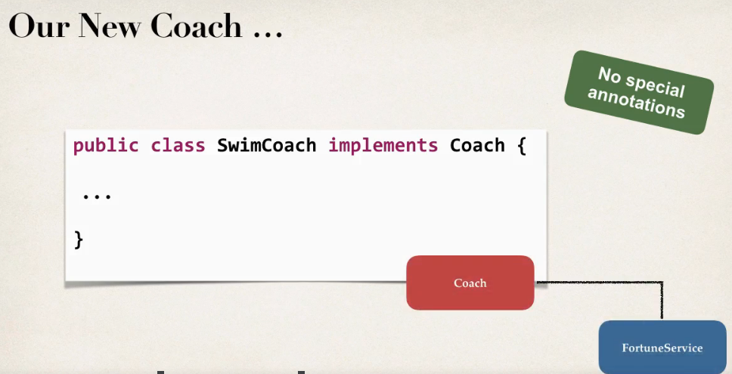

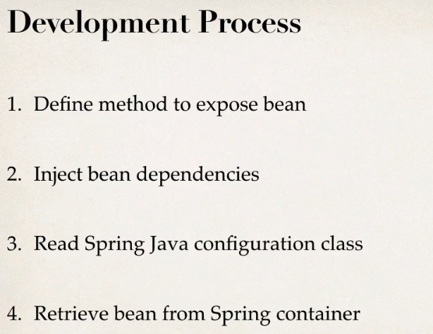

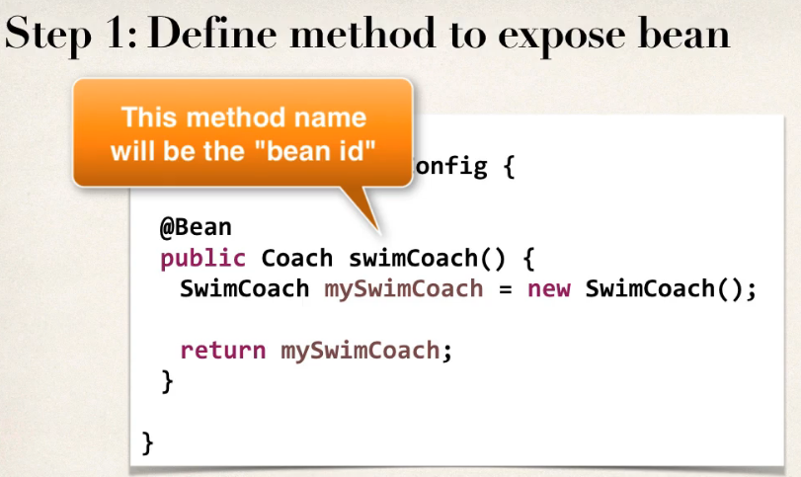

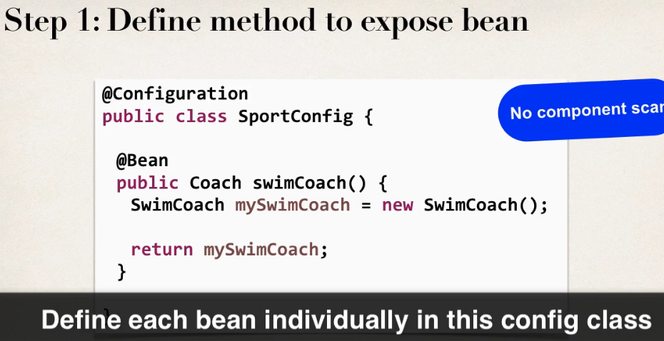

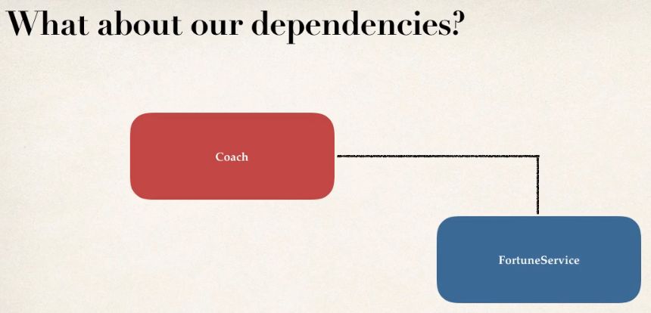

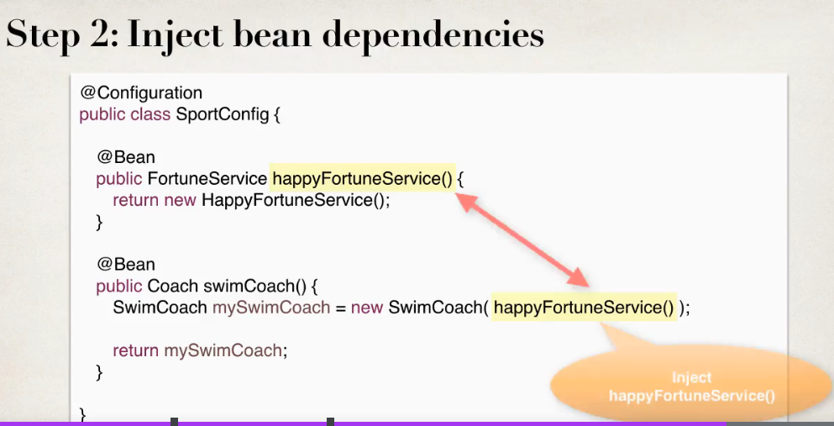

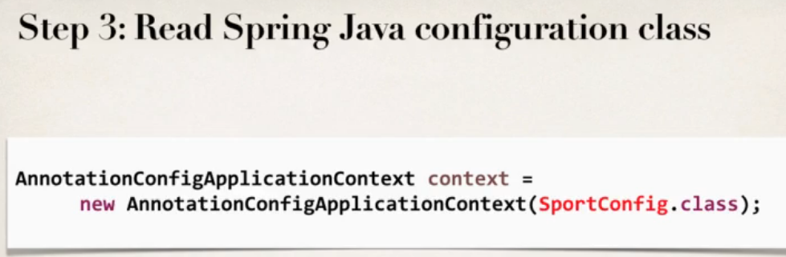

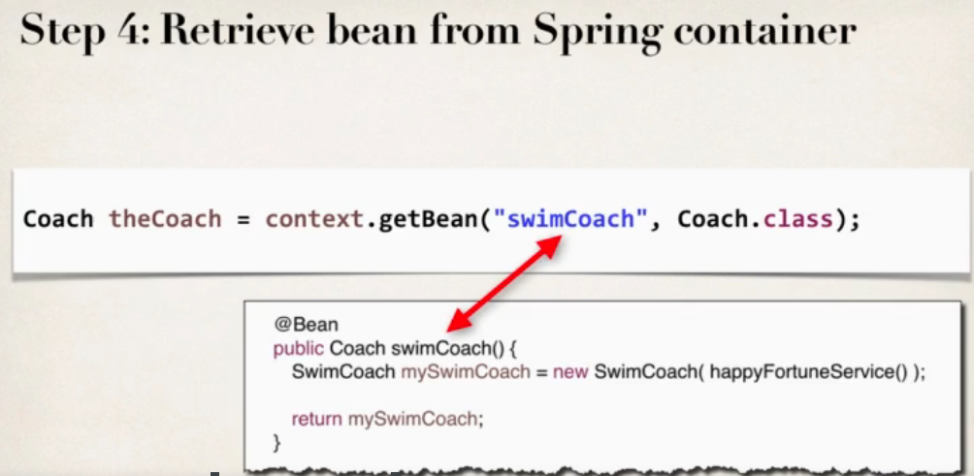

## How bean works behind the scenes

**Question:**

During All Java Configuration, how does the @Bean annotation work in the background?

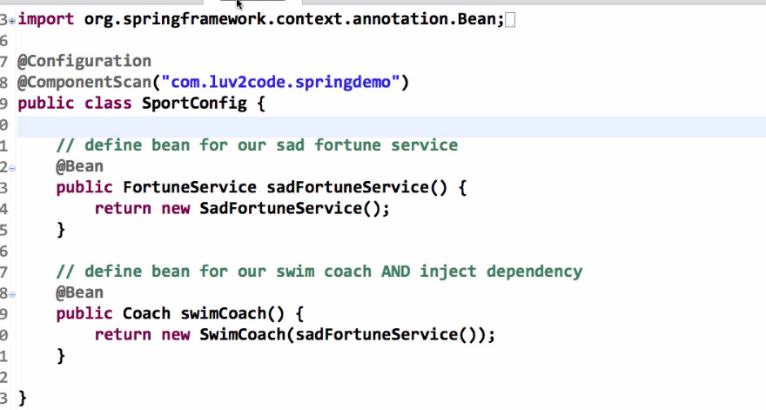

**Answer**

For this code:

1. @Bean
2. public Coach swimCoach() {
3. SwimCoach mySwimCoach = new SwimCoach();
4. return mySwimCoach;
5. }

At a high-level, Spring creates a bean component manually. By default the scope is singleton. So any request for a "swimCoach" bean, will get the same instance of the bean since singleton is the default scope.

However, let's break it down line-by-line

1. @Bean

The @Bean annotation tells Spring that we are creating a bean component manually. We didn't specify a scope so the default scope is singleton.

1. public Coach swimCoach(){

This specifies that the bean will bean id of "swimCoach". The method name determines the bean id. The return type is the Coach interface. This is useful for dependency injection. This can help Spring find any dependencies that implement the Coach interface.

The @Bean annotation will intercept any requests for "swimCoach" bean. Since we didn't specify a scope, the bean scope is singleton. As a result, it will give the same instance of the bean for any requests.

1. SwimCoach mySwimCoach = new SwimCoach();

This code will create a new instance of the SwimCoach.

1. return mySwimCoach;

This code returns an instance of the swimCoach.

----

Now let's step back and look at the method in it's entirety.

1. @Bean
2. public Coach swimCoach() {
3. SwimCoach mySwimCoach = new SwimCoach();
4. return mySwimCoach;
5. }

It is important to note that this method has the @Bean annotation. The annotation will intercept ALL calls to the method "swimCoach()". Since no scope is specified the @Bean annotation uses singleton scope. Behind the scenes, during the @Bean interception, it will check in memory of the Spring container (applicationContext) and see if this given bean has already been created.

If this is the first time the bean has been created then it will execute the method as normal. It will also register the bean in the application context. So that is knows that the bean has already been created before. Effectively setting a flag.

The next time this method is called, the @Bean annotation will check in memory of the Spring container (applicationContext) and see if this given bean has already been created. Since the bean has already been created (previous paragraph) then it will immediately return the instance from memory. It will not execute the code inside of the method. Hence this is a singleton bean.

The code for

1. SwimCoach mySwimCoach = new SwimCoach();
2. return mySwimCoach;

is not executed for subsequent requests to the method public Coach swimCoach() . This code is only executed once during the initial bean creation since it is singleton scope.

That explains how @Bean annotation works for the swimCoach example.

====

Now let's take it one step further.

Here's your other question

**>> Please explain in detail whats happening behind the scene for this statement.**

return new SwimCoach(sadFortuneService())

The code for this question is slightly different. It is injecting a dependency.

In this example, we are creating a SwimCoach and injecting the sadFortuneService().

1. // define bean for our sad fortune service
2. @Bean
3. public FortuneService sadFortuneService() {
4. return new SadFortuneService();
5. }
7. // define bean for our swim coach AND inject dependency
8. @Bean
9. public Coach swimCoach() {
10. SwimCoach mySwimCoach = new SwimCoach(sadFortuneService());
12. return mySwimCoach;
13. }

Using the same information presented earlier

The code

// define bean for our sad fortune service

@Bean

public FortuneService sadFortuneService() {

return new SadFortuneService();

}

In the code above, we define a bean for the sad fortune service. Since the bean scope is not specified, it defaults to singleton.

Any calls for sadFortuneService, the @Bean annotation intercepts the call and checks to see if an instance has been created. First time through, no instance is created so the code executes as desired. For subsequent calls, the singleton has been created so @Bean will immediately return with the singleton instance.

Now to the main code based on your question.

return new SwimCoach(sadFortuneService())

This code creates an instance of SwimCoach. Note the call to the method sadFortuneService(). We are calling the annotated method above. The @Bean will intercept and return a singleton instance of sadFortuneService. The sadFortuneService is then injected into the swim coach instance.

This is effectively dependency injection. It is accomplished using all Java configuration (no xml).

---

This concludes the line-by-line discussion of the source code. All of the behind the scenes work.

## What is real time use case of bean

Here is a real-time use case of using @Bean: You can use @Bean to make an existing third-party class available to your Spring framework application context.

For example, I was recently working on a global real-time project using Amazon Web Services. The project made use of the [Amazon Simple Storage Service (AWS S3)](https://aws.amazon.com/s3/). This is remote service that provides object storage in the cloud. You can think of AWS S3 at a high-level as a remote file server for storing files (pdfs, pngs etc).

Our Spring application needed to integrate with AWS S3 and store pdf documents. Amazon provides an AWS SDK for integrating with AWS S3. Their API provides a class, [S3Client](https://sdk.amazonaws.com/java/api/latest/software/amazon/awssdk/services/s3/S3Client.html). This is a regular Java class that provides a client interface to the AWS S3 service. We needed to share the S3Client object in various services in our Spring application. However, the S3Client does not have the @Component annotation. The S3Client does not use Spring.

Since the S3Client is part of the AWS framework, we can't modify the source code for the S3Client directly. We can't simply add the @Component annotation to the S3Client source code. As a result, we need an alternative solution.

But no problem, by using the @Bean annotation, I can wrap this third-party class, S3Client, as a Spring bean. And then once it is wrapped using @Bean, it is as a singleton object and available in our Spring framework application context. I can now easily share this bean in my app using dependency injection and @Autowired. So think of the @Bean annotation was a wrapper / adapter for third-party classes. You want to make the third-party classes available to your Spring framework application context.

**Here's a real-time example**

Here is a snippet from our @Configuration class. We create an instance of the S3Client and wrap it as a Spring bean. The default scope is singleton. It is now available in our application context and we can inject it to other parts of our Spring application using @Autowired.

1. @Bean
2. public S3Client remoteClient() {
4. // Create an S3 client to connect to AWS S3
5. S3Client s3Client = S3Client.builder().region(Region.of(region))
6. .credentialsProvider(StaticCredentialsProvider.create(awsCreds)).build();
8. return s3Client;
9. }

---

In the code below, this is a Spring service that uses the S3Client. The service @Service annotation is a subclass of @Component. This code uses @Autowired to inject the bean named "remoteClient". This bean was created in the configuration code above using @Bean.

Once the bean is injected, then our method can use this to interact with the Amazon S3 service. In this real-time project, we were processing insurance claims. We store the PDF invoices in the cloud using the AWS S3 service.

1. @Service
2. public class InsuranceClaimsServiceImpl implements ClaimsService {
4. @Autowired
5. private S3Client remoteClient;
7. ...
9. public void processClaim(Claim theClaim) {

12. // read claim data
13. FileData fileData = theClaim.getFileData("payerInvoice");
14. String fileName = theClaim.getSubmittedFileName();
16. // get the input stream and file size
17. InputStream fileInputStream = fileData.getInputStream();
18. long contentLength = fileData.getSize();
20. //
21. // store claim data in AWS S3
22. //
24. // Create a put request for the object
25. PutObjectRequest putObjectRequest = PutObjectRequest.builder()
26. .bucket(bucketName)
27. .key(subDirectory + "/" + fileName)
28. .acl(ObjectCannedACL.BUCKET_OWNER_FULL_CONTROL).build();
30. // perform the putObject operation to AWS S3 ... using our autowired bean
31. remoteClient.putObject(putObjectRequest, RequestBody.fromInputStream(fileInputStream, contentLength))
32. }
33. }

As you can see, I was able to wrap a third-party class as a Spring bean. The AWS S3Client object was not originally annotated with @Component. The S3Client is not aware of Spring. But I could manually wrap it using @Bean. By doing this, the object is now available in our Spring application context. We can now share/reuse this bean in other areas of our Spring app by using dependency injection and @Autowired.

For other services in our application, if they need access to the S3client (singleton) then they can simply inject it using @Autowired. No need for each service to create a new instance of the S3Client every time. This keeps the application efficient in terms of memory and performance.

---

In summary: *You can use @Bean to make an existing third-party class available to your Spring framework application context.*

**Note:** You can use both two approaches of @Bean AND component scanning depending on your application requirements. You can use @Bean for third-party beans. For your existing beans in your class you can use component scanning with @Component (also @Controller, @Service, @Repository ...).

## Injecting values from properties file

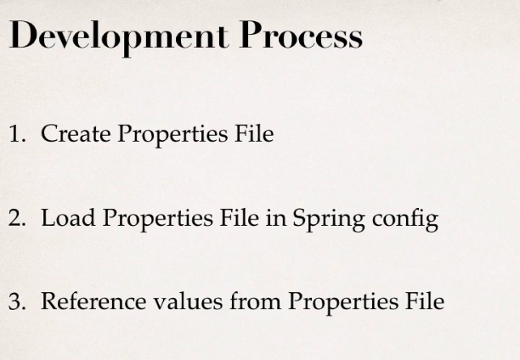

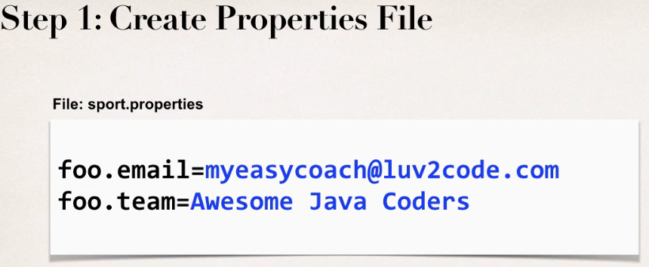

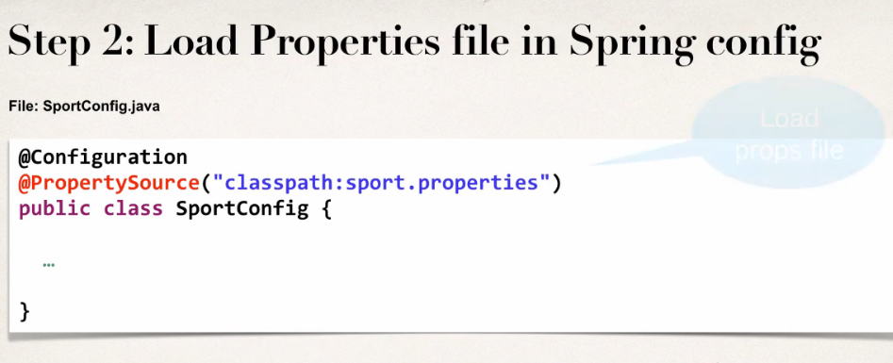



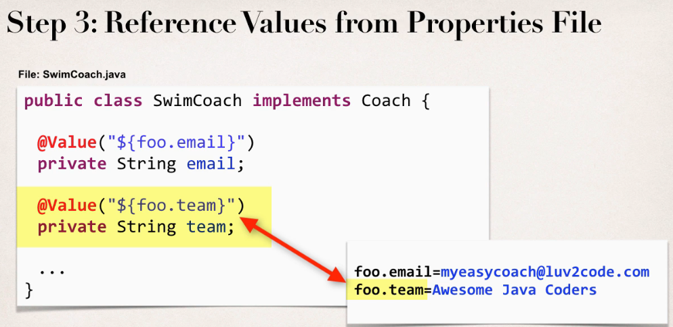

## Difference between BeanFactory and ApplicationContext in Spring framework

Both BeanFactory and ApplicationContext provide a way to get a bean from the Spring IOC container by calling getBean("bean name"), but there is some difference in their working and features provided by them. One difference between the bean factory and application context is that the former only instantiates bean when you call getBean() method while ApplicationContext instantiates Singleton bean when the container is started,  It doesn't wait for the getBean to be called  
  
Syntactically BeanFactory and ApplicationContext both are [Java interfaces](http://javarevisited.blogspot.in/2012/04/10-points-on-interface-in-java-with.html) and ApplicationContext extends BeanFactory.  Both of them are configuration using [XML configuration files](http://javarevisited.blogspot.in/2012/03/how-to-read-properties-file-in-java-xml.html), now application context also allows Java configuration.   
  
In short, BeanFactory provides basic IOC and DI features while ApplicationContext provides advanced features. Apart from these, here are a few more differences between BeanFactory and ApplicationContext which is mostly based upon features supported by them.

**1. Internationalization (i18n)**

BeanFactory doesn't provide support for internationalization i.e. i18n but ApplicationContext provides support for it.

**2. Event Publishing**

Another difference between BeanFactory vs ApplicationContext is the ability to publish events to beans that are registered as listeners. For example, a ContextStartedEvent is published when the context is started and ContextStoppedEvent is published when the context is stopped. Event handling in the ApplicationContext is provided through the ApplicationEvent class and ApplicationListener interface.

**3. Implementations**

One of the popular implementations of the BeanFactory interface is XMLBeanFactory while one of the popular implementations of the ApplicationContext interface is ClassPathXmlApplicationContext. On [Java web application](http://javarevisited.blogspot.sg/2012/08/what-is-jsessionid-in-j2ee-web.html) we use WebApplicationContext which extends the ApplicationContext interface and adds the getServletContext method.

**4. Autowiring**

If you are using auto wiring and using BeanFactory then you need to register AutoWiredBeanPostProcessor using API which you can configure in XML if you are using  ApplicationContext.   
  
In summary, BeanFactory is OK for testing and non-production use but ApplicationContext is more feature-rich container implementation and should be favored over BeanFactory

I mostly use XML configuration file and ClassPathXmlApplicationContext to quickly run any Spring-based Java program from [Eclipse](http://javarevisited.blogspot.sg/2012/10/eclipse-shortcut-to-remove-all-unused-imports-java.html) by using the following snippet of code :

**public** **static** **void** main(**String** args[]){  
    ApplicationContext ctx =**new** ClassPathXmlApplicationContext("beans.xml");  
    Hello hello =(Hello) ctx.getBean("hello");  
    hello.sayHello("John");  
}

here beans.xml is your spring configuration file and “hello” is a bean defined in that spring configuration file. Here we have used ClassPathXmlApplicationContext which is an implementation of the ApplicationContext interface in Spring.

And, if you want to learn more then you can further see a comprehensive Spring course like[**Spring MasterClass from Beginner to Expert**](https://click.linksynergy.com/fs-bin/click?id=JVFxdTr9V80&subid=0&offerid=323058.1&type=10&tmpid=14538&RD_PARM1=https%3A%2F%2Fwww.udemy.com%2Fspring-tutorial-for-beginners%2F) to understand more about the basic Spring concepts.

[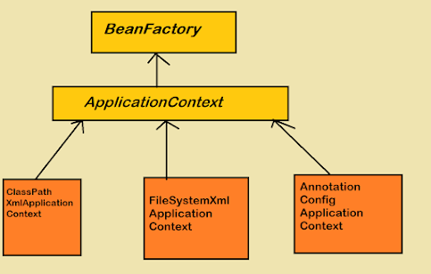](https://click.linksynergy.com/fs-bin/click?id=JVFxdTr9V80&subid=0&offerid=323058.1&type=10&tmpid=14538&RD_PARM1=https%3A%2F%2Fwww.udemy.com%2Fspring-tutorial-for-beginners%2F)

These were some worth noting **differences between BeanFactory and ApplicationContext in the Spring framework**. In most practical cases you will be using ApplicationContext but knowing about BeanFactory is important to understand the fundamental concept of the spring framework.

Read more: <https://javarevisited.blogspot.com/2012/11/difference-between-beanfactory-vs-applicationcontext-spring-framework.html#ixzz7QtMPFoda>

# Spring bean life cycle

By -default spring scope is singleton

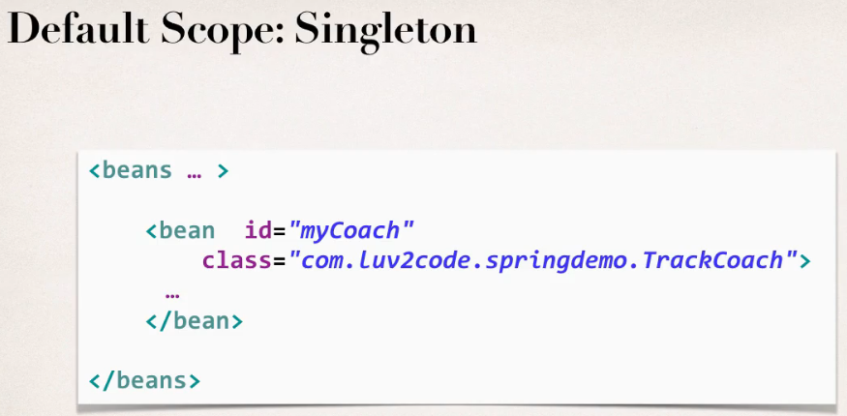

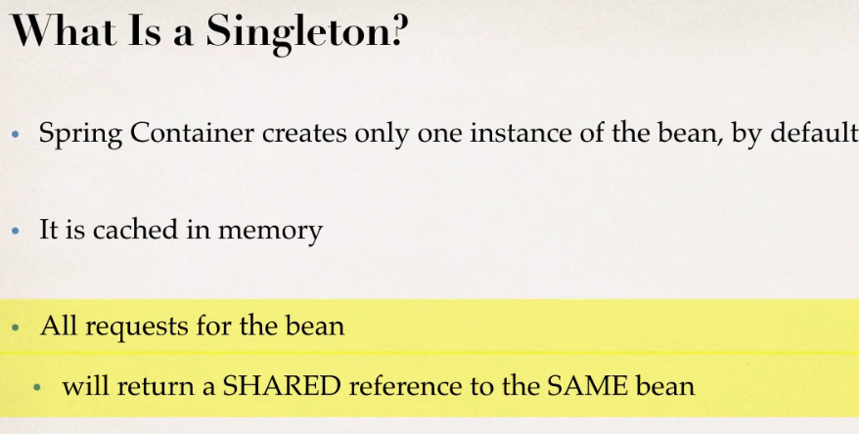

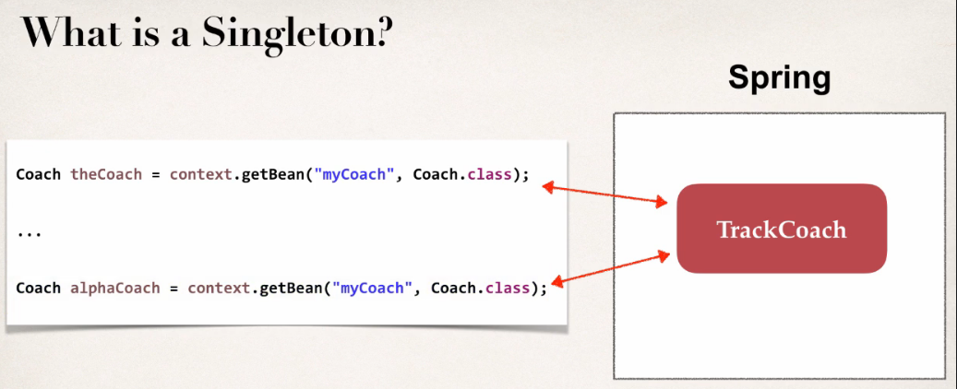

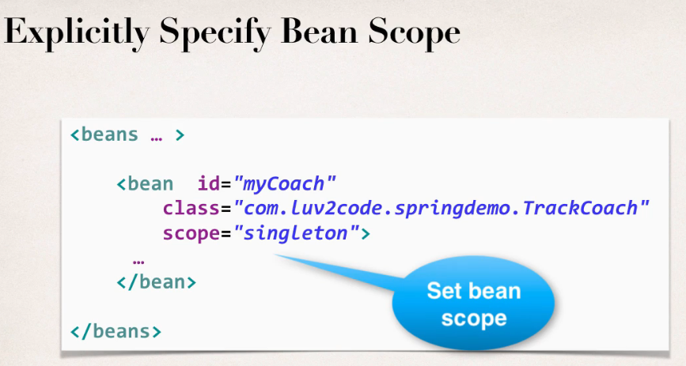

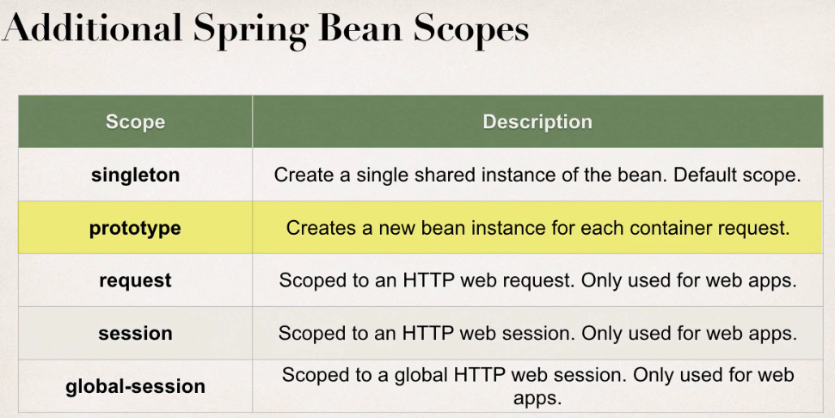

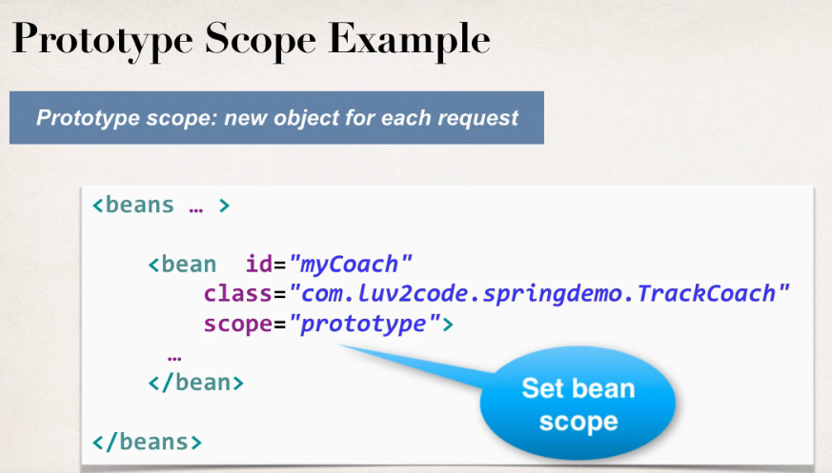

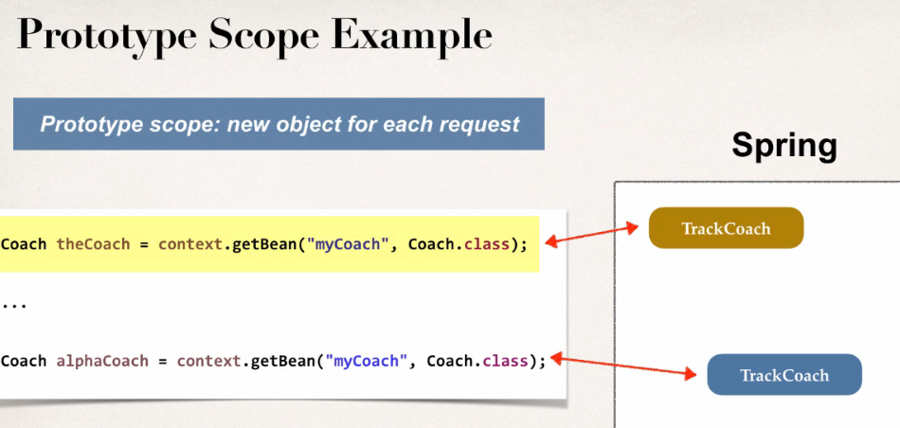

Code Example with default Scope or singleton scope of a bean:

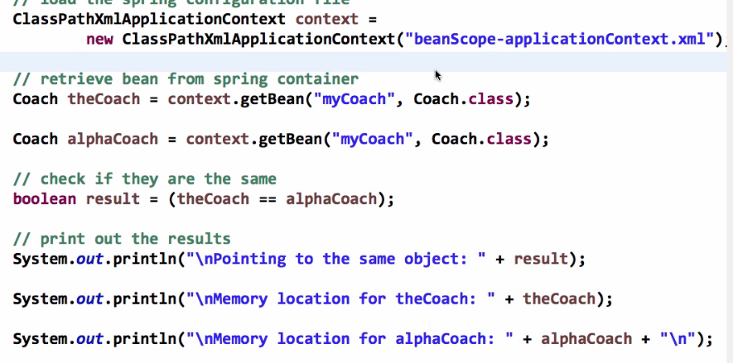

Output:

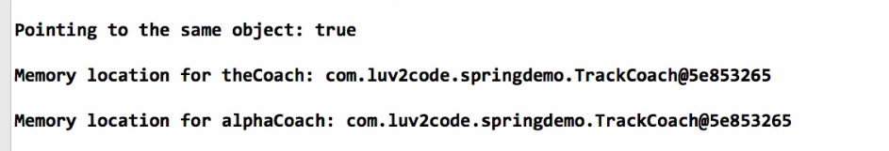

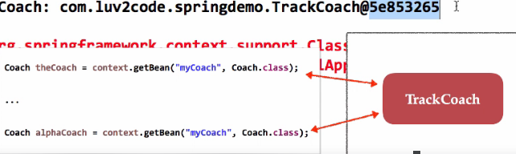

Now just change the scope and try

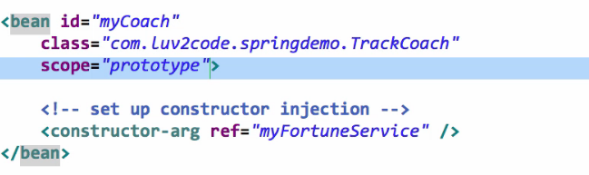

Now run the application and check out the reference variables

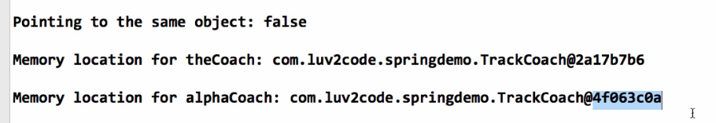

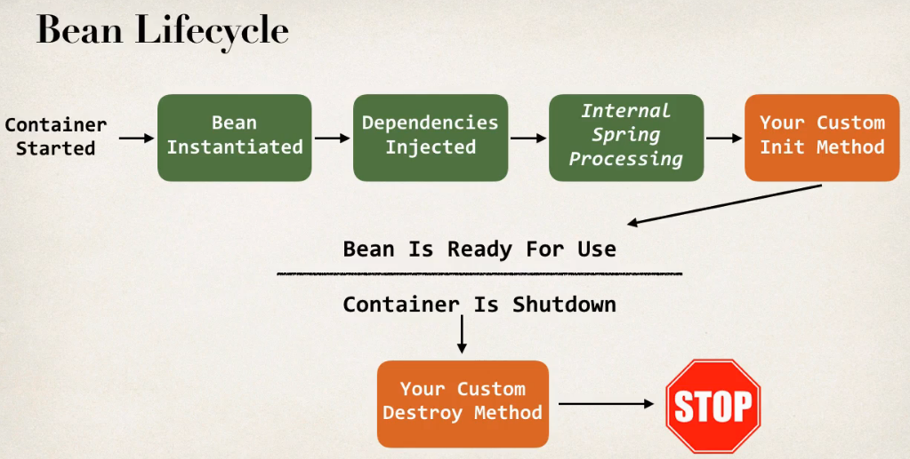

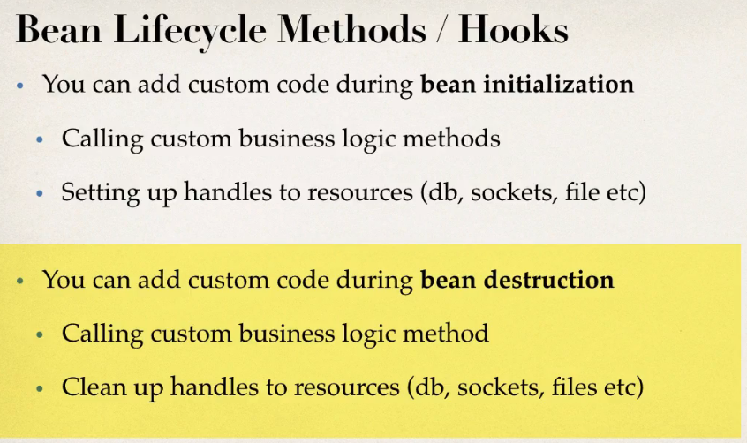

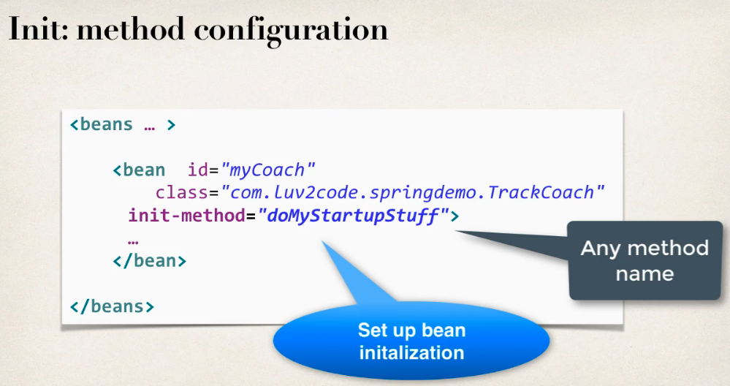

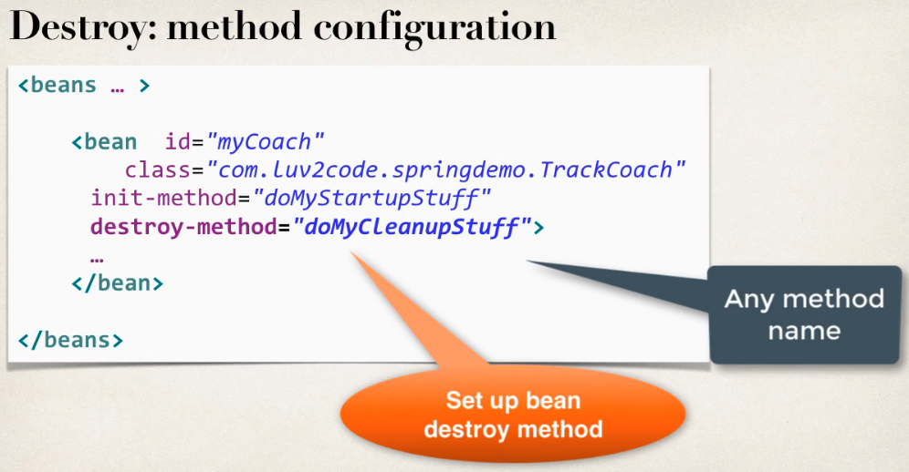

Defining init and destroy methods:

**Special Note about init and destroy Method Signatures**

When using XML configuration, I want to provide additional details regarding the method signatures of the init-method  and destroy-method .

**Access modifier**  
The method can have any access modifier (public, protected, private)

**Return type**  
The method can have any return type. However, "void' is most commonly used. If you give a return type just note that you will not be able to capture the return value. As a result, "void" is commonly used.

**Method name**  
The method can have any method name.

**Arguments**  
The method can not accept any arguments. The method should be no-arg.

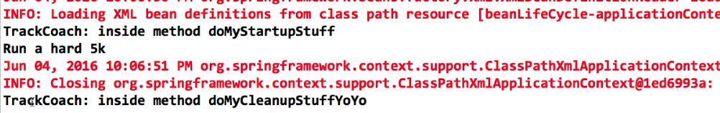

There is a subtle point you need to be aware of with "prototype" scoped beans.

**For "prototype" scoped beans, Spring does not call the destroy method.  Gasp!**

**In contrast to the other scopes, Spring does not manage the complete lifecycle of a prototype bean**: the container instantiates, configures, and otherwise assembles a prototype object, and hands it to the client, with no further record of that prototype instance.

Thus, although initialization lifecycle callback methods are called on all objects regardless of scope, **in the case of prototypes, configured destruction lifecycle callbacks are not called**. The client code must clean up prototype-scoped objects and release expensive resources that the prototype bean(s) are holding.

This also applies to both XML configuration and Annotation-based configuration.

***QUESTION: How can I create code to call the destroy method on prototype scope beans***

You can destroy prototype beans but custom coding is required using DisposableBean

# Spring ORM

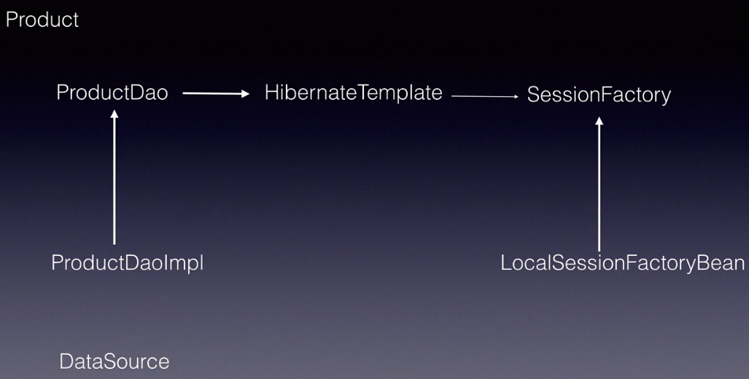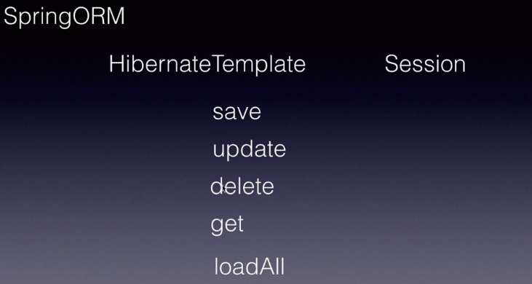

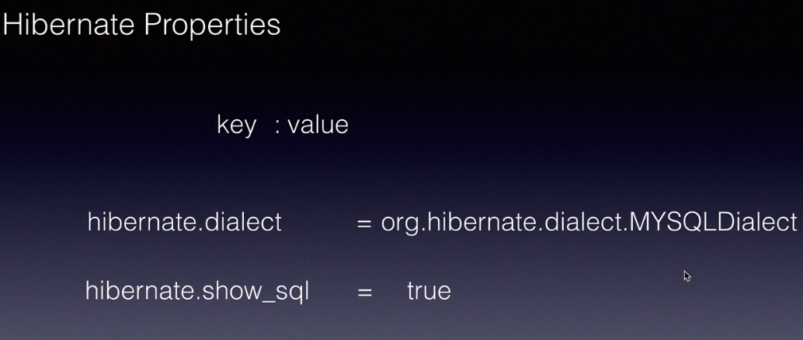 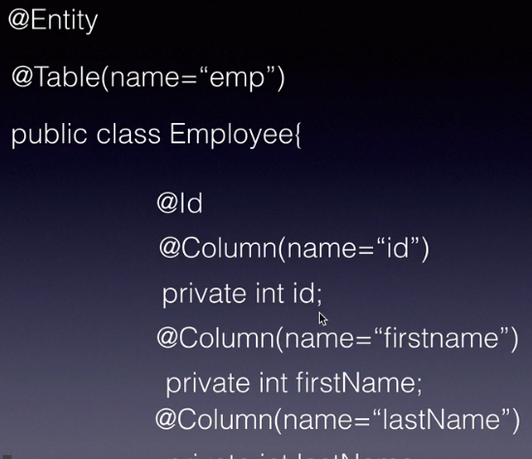

ORM mapping can be done in 2 ways

1: Using XML

2: Annotations (Entity,Table,Id,Column)

Create a maven quickstart project ->Dependecies – spring-core (Dependecy injection),

spring-context,

mysql-connector,maven-compiler

Spring ORM, Hibernate-core

# Spring MVC

A Spring MVC is a Java framework which is used to build web applications. It follows the Model-View-Controller design pattern. It implements all the basic features of a core spring framework like Inversion of Control, Dependency Injection.

Spring MVC uses 3 different pattern namly frontController ,HandlerMapper and ViewResolver to implement MVC framework, when a request comes in from the end client It first reaches the frontController which is a dispatcher servlet that we configure in a web.xml file, then dispacther servlet forward this request to handlerMapper , HandlerMapper is responsible for mapping the incoming request to a controller class that we create , we mark these class with @Controller annotation , the handler mapper using the url in request and maps it to the appropriate controller, The controller handles the request takes the appropriate action and finally in the end it returns a ModelAndView where Model represents the data and View represents the next UI to which the response should be send. The controller return a ModelAndView back to the frontController , The dispatcher servlet then invoke the ViewResolver which is component which is responsible for adding a location and extension for the view that controller returns. Once the front controller has the complete view , it will generate that view and send response back to the client . To exchange data between controller to the UI we use ModelAndView object and to get the data from UI to the controller we use @ModelAttribute annotations the name of html should be same as names in model class.

In the recent version of spring ModelAndView is split into ModelMap(Model) and String (View)

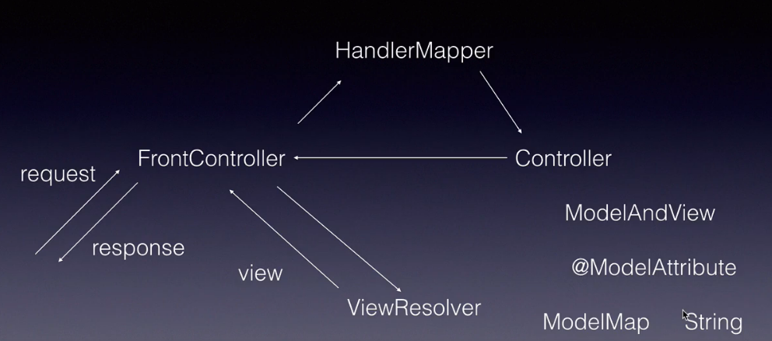

Spring core and spring context we get it by default we set achetype-web mvc

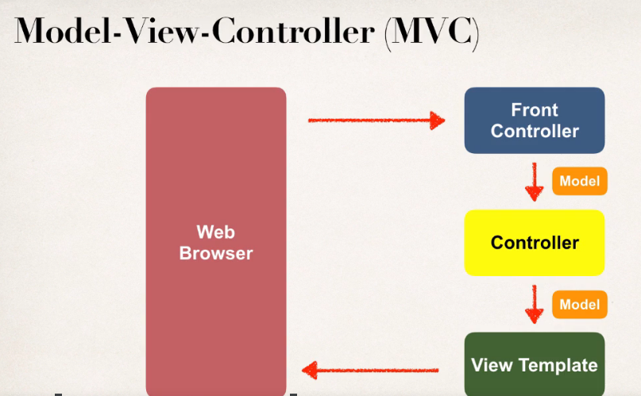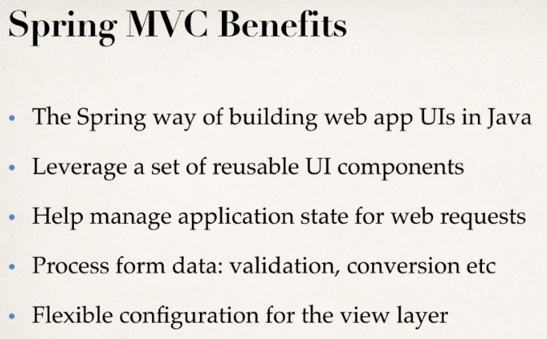

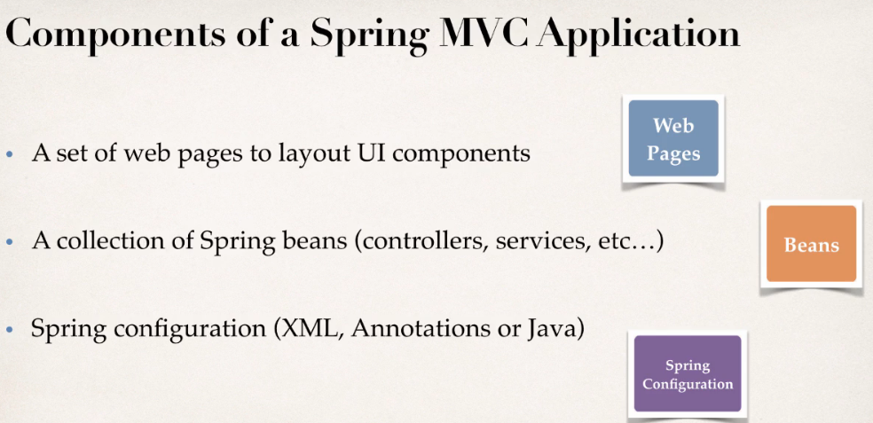 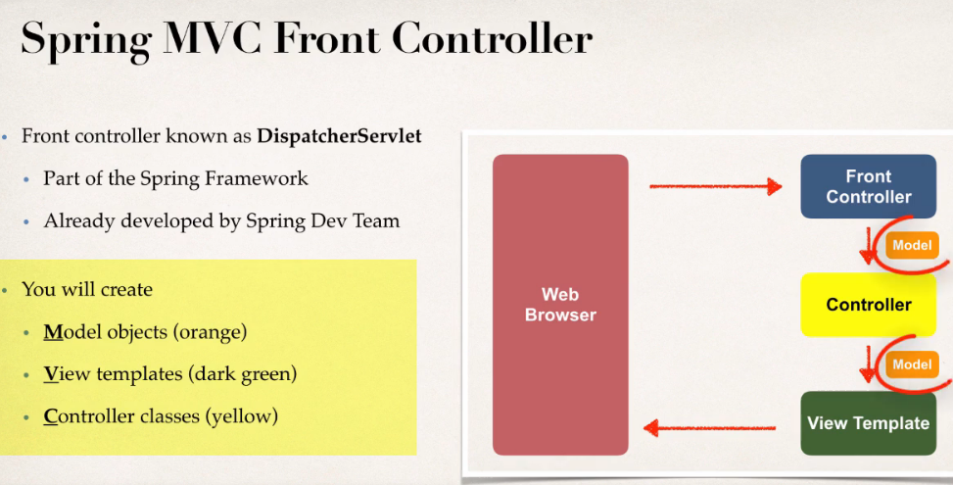

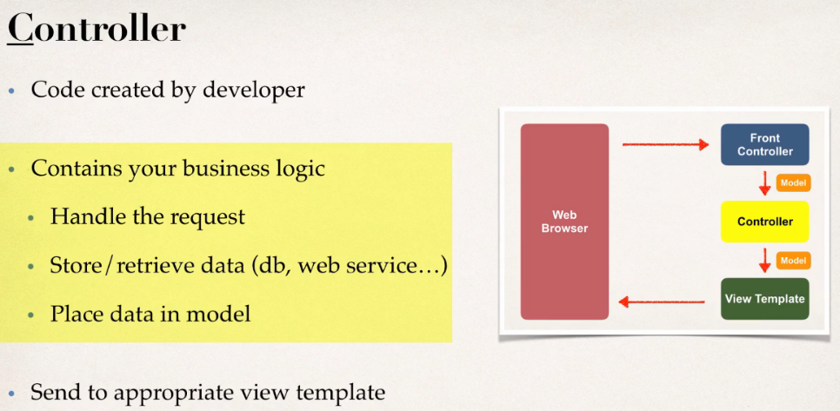 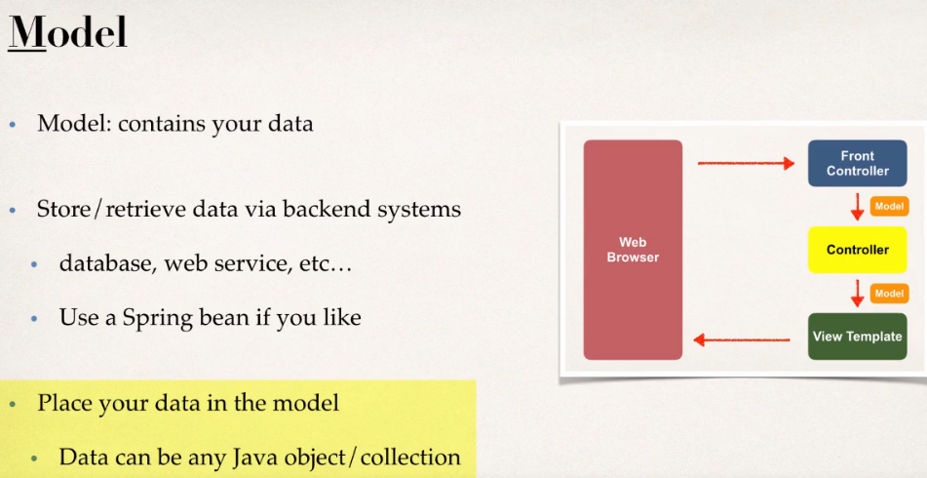

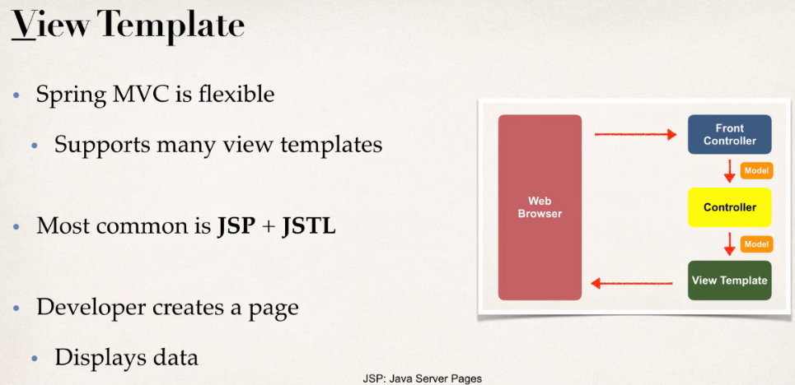

## Spring MVC configuration process steps

Check out spingmvc project on eclipse

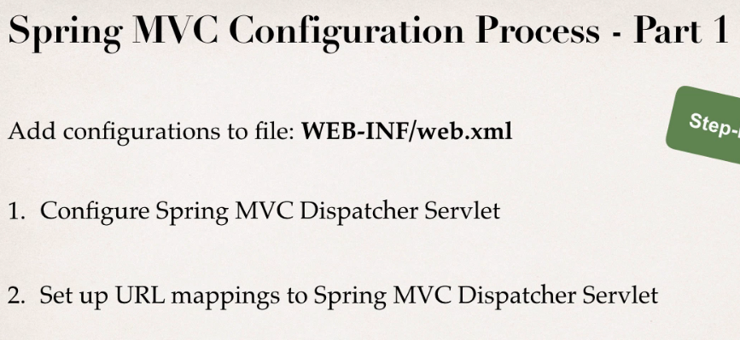 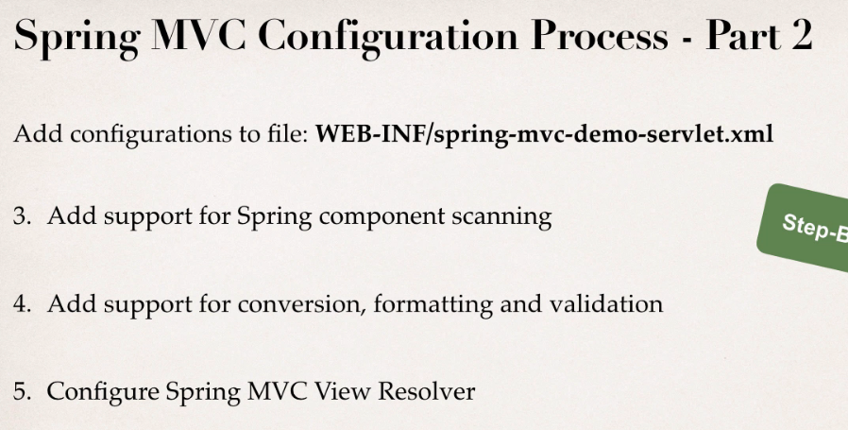

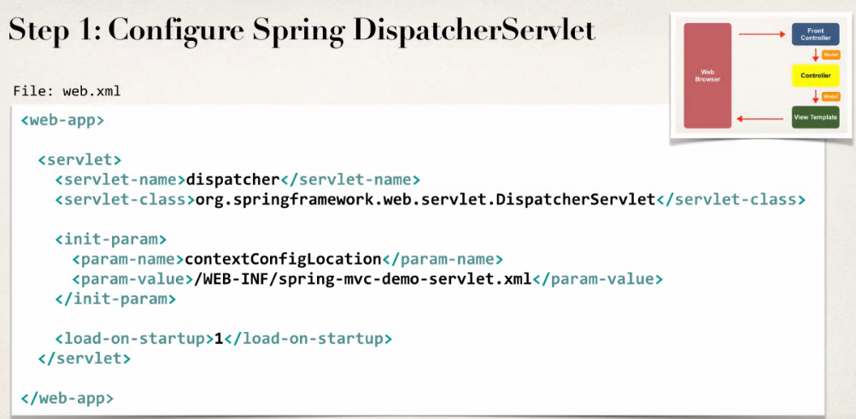 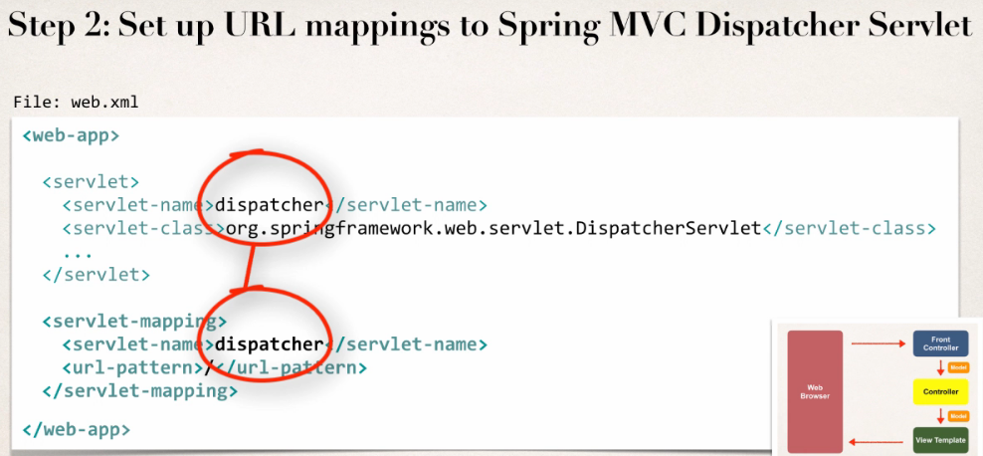

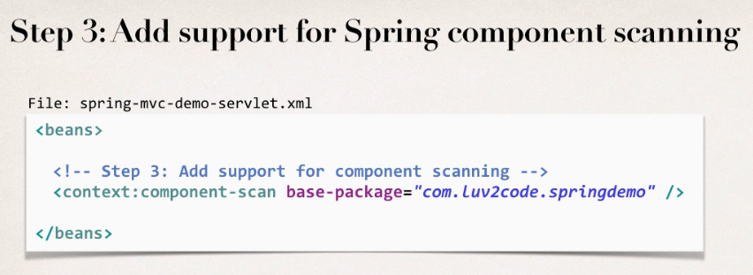 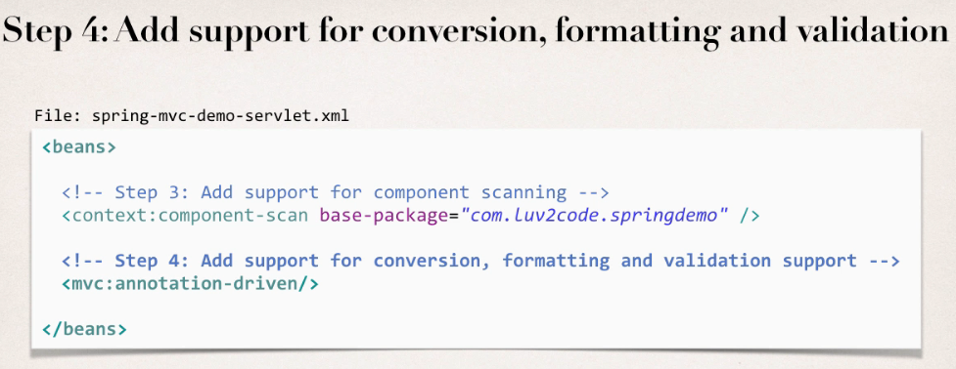

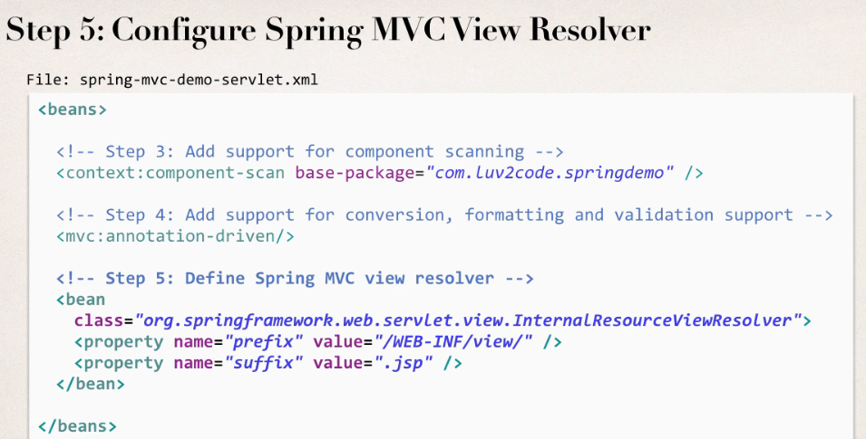

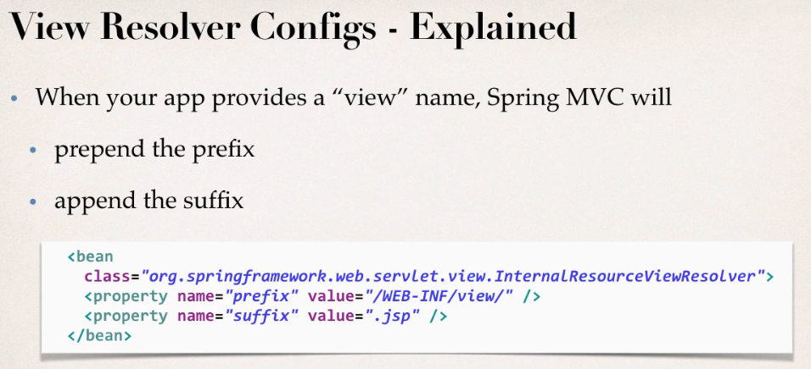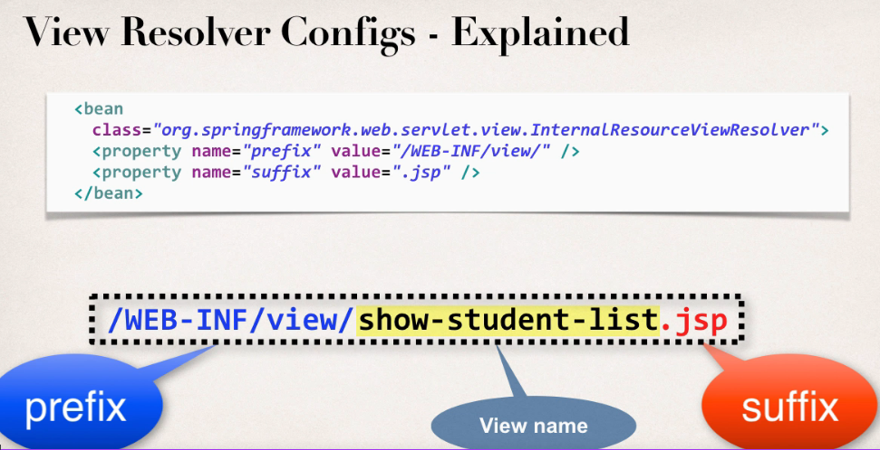

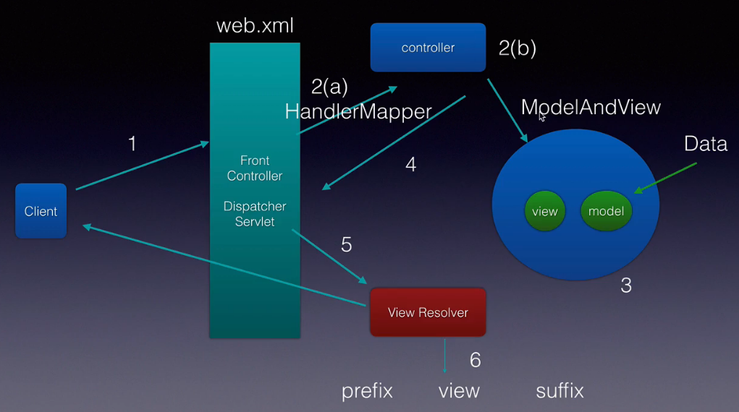

## Dispatcher Servlet in Spring

A Spring MVC provides an elegant solution to use MVC in spring framework by the help of **DispatcherServlet**. Here, **DispatcherServlet** is a class that receives the incoming request and maps it to the right resource such as controllers, models, and views.

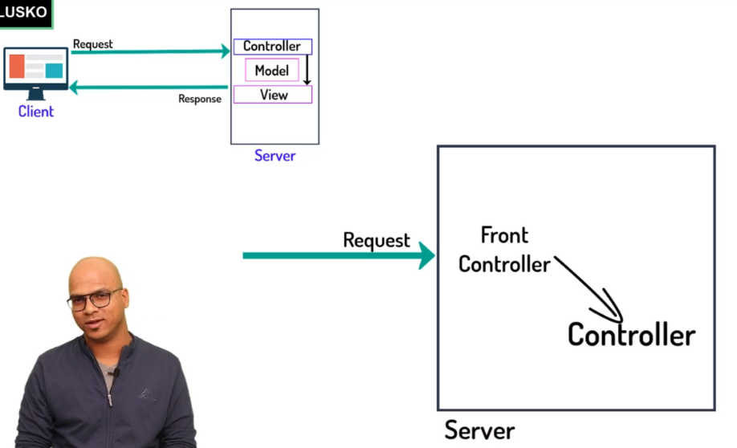

## Adding 2 number using spring mvc in jsp page

public String home() {

System.out.println("Home method");

return "index.jsp";

}

This will download the jsp page for this we need to add jasper dependency

NOTE : If you want to work with JSP page in MVC we need Tomcat jasper lib who will convert jsp into servlet .

Adding 2 numbers in MVC

<form action="add">

<input type="text" name="num1">

<input type="text" name="num2">

<input type="submit">

</form>

Controller Code

Method 1:

@RequestMapping("/add")

public String add(HttpServletRequest req) {

int i=Integer.parseInt(req.getParameter("num1"));

int i2=Integer.parseInt(req.getParameter("num2"));

HttpSession session=req.getSession();

session.setAttribute("num3", (i+i2));

//return "result.jsp?num3="+(i+i2);

return "result.jsp";

}

Using request param and Httpsession

@RequestMapping("/add")

public String add(@RequestParam("num1") int i,@RequestParam("num2") int j,HttpSession session) {

session.setAttribute("num3", (i+j));

return "result.jsp";

}

Using Model And View

@RequestMapping("/add")

public ModelAndView add(@RequestParam("num1") int i,@RequestParam("num2") int j) {

ModelAndView mv= new ModelAndView();

mv.setViewName("result");

mv.addObject("num3",i+j);

return mv;

}

Use of prefix and suffix:

After adding these to properties in the application.properties file we do not need to specify the .jsp in the controller .

spring.mvc.view.prefix=/views/

spring.mvc.view.suffix=.jsp

What is the difference between Model , ModelMap vs ModelAndView in spring mvc ?

When In some senariores we do not want to work on data in that case we can use ModelMap and String (ViewName)

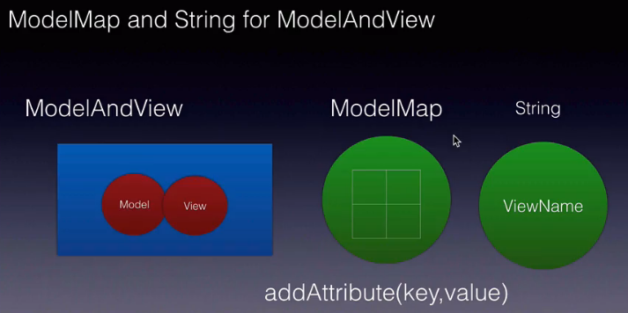 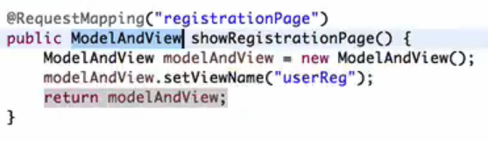

In this above SS there is no need of ModelAndView as we not sending any data to the view, its just returning a view . Instead what we can do is using String and ModelMap, the code will be simpler and cleaner

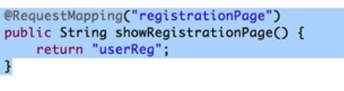 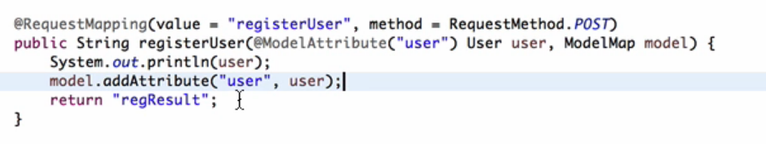

@RequestMapping("/add")

public String add(@RequestParam("num1") int i,@RequestParam("num2") int j,Model m) {

m.addAttribute("num3",i+j);

return "result";

}

Here in the above code we are not returning modelAndView object just returing string.

## ModelAttribute Annotation

Without ModelAttribute

If some times a query parameter is optional In that case we can make required=false in @RequestParam and we can give default value to a url param

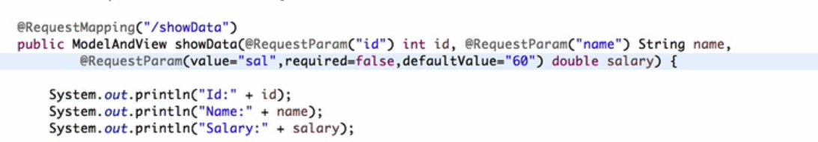

@RequestMapping("/addUser")

public String add(@RequestParam("id")int i,@RequestParam("name") String name,Model m) {

User user=new User();

user.setId(i);

user.setName(name);

m.addAttribute("user",user);

return "result";

}

Using ModelAttribute

<form action="addUserUsingModelAttribute">

Id:<input type="text" name="id">

Name:<input type="text" name="name">

<input type="submit">

</form>

@RequestMapping("/addUserUsingModelAttribute")

public String add(@ModelAttribute User user,Model m) {

m.addAttribute("user",user);

return "result";

}

Or

@RequestMapping("/addUserUsingModelAttribute")

public String add(@ModelAttribute User user) {

return "result";

}

If you are not using @ModelAttribute then name should same in View and In controller parameter.

@RequestMapping("/addUserWithSpecifyingMA")

public String addWithoutMA(User user) {

return "result";

}

Spring boot says you don’t have worry about configurations.

Spring web mvc dependency provides all these annotations , we can create maven quickstart web app where we need to manually add dependencies and in web.xml we also need to configure dispatcher servlet

<https://www.javatpoint.com/spring-vs-spring-boot-vs-spring-mvc>

## Spring HandlerMapping

<https://docs.spring.io/spring-framework/docs/3.0.0.M3/reference/html/ch16s04.html>

## Sending data from controller to view

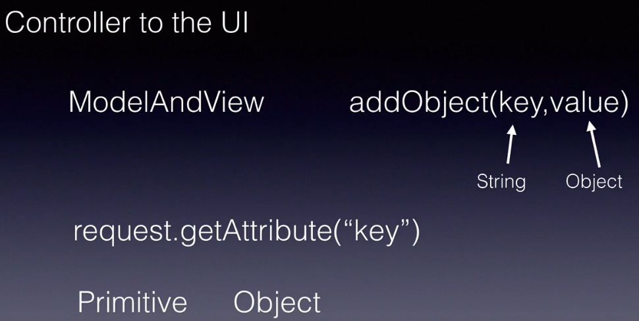

Sending primitive types :

@Controller

public class HelloController {

@RequestMapping("/hello")

public ModelAndView hello() {

ModelAndView mv = new ModelAndView();

mv.setViewName("hello");

mv.addObject("id", 12);

mv.addObject("name", "aman");

mv.addObject("salary", 10000);

return mv;

}

}

<%@ page isELIgnored="false" %> //if this is not added then expression language will not work

<html>

<body>

<h2>Using JSP</h2>

<%

Integer objj = (Integer) request.getAttribute("id");

String name = (String) request.getAttribute("name");

Integer sal = (Integer) request.getAttribute("salary");

out.println(name+" "+sal);

%>

<h2><%out.print(name);%></h2>

<h3>Using Expression language</h3>

Id: <b>${id}</b><br>

<p>Name: ${name}</p>

Salary: <b>${salary}</b><br>

</body>

</html>

Sending the object Data to view

@RequestMapping("/employee")

public ModelAndView sendObject() {

ModelAndView mv=new ModelAndView();

mv.setViewName("employee");

Employee emp=new Employee();

emp.setId(1);

emp.setName("Aman");

emp.setSalary(500000);

mv.addObject("employee",emp);

return mv;

}

Sending list of objects

<%@ page language="java" isELIgnored="false" import="com.aman.springmvc.dto.*, java.util.* "%>

<body>

List of emps,

<div>

<%

ArrayList<Employee> empss=(ArrayList<Employee>)request.getAttribute("employees");

out.println(empss);

for(Employee e:empss){

out.println(e);

}

%>

</div>

</body>

## Sending data from UI to controller

Using Form object

Using query parameter

## WebApplicationInitializer and WebMvcConfigurerAdapter

If we are not doing xml configuration then we need webapplicationInitializer

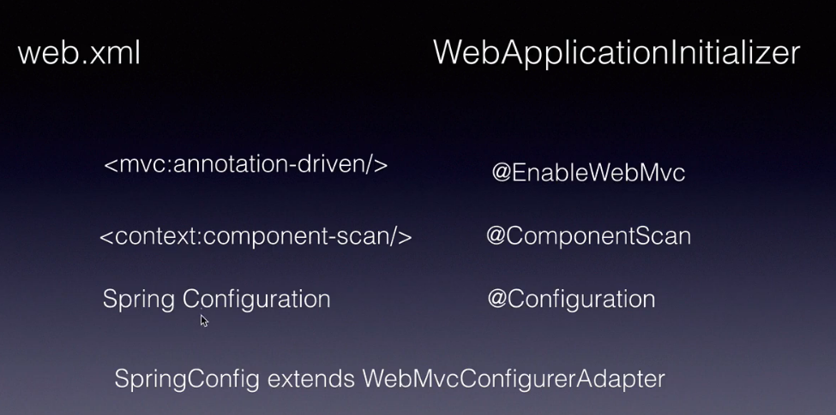



<https://zetcode.com/spring/webapplicationinitializer/>

If we are doing annotation based configuration in that case we can not delete web.xml because by default spring searches for this , In this situation we can add war plugin which we tell that we are doing annotation based configuration.

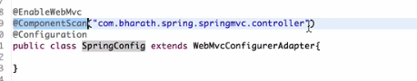

Configuring ViewResolver using annotation

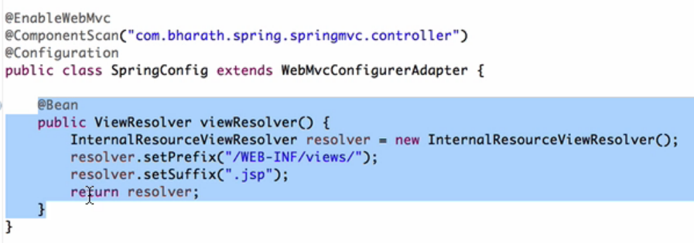

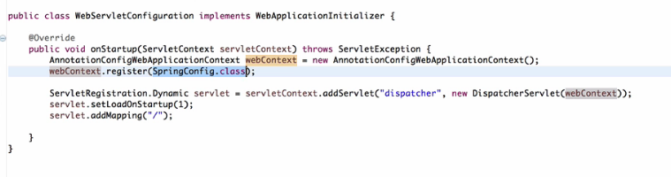

# Spring Boot

Makes spring simpler

Convention over configuration

Opinionated Defaults

No XML- when it finds any dependency spring will automatically configure the dependency

@SpringBootApplication: if we are marking a particular class with this annotation it means that it is the starting point of our spring boot application, it has automatically @Configuration, @EnableAutoCon..and @ComponentScan annotation

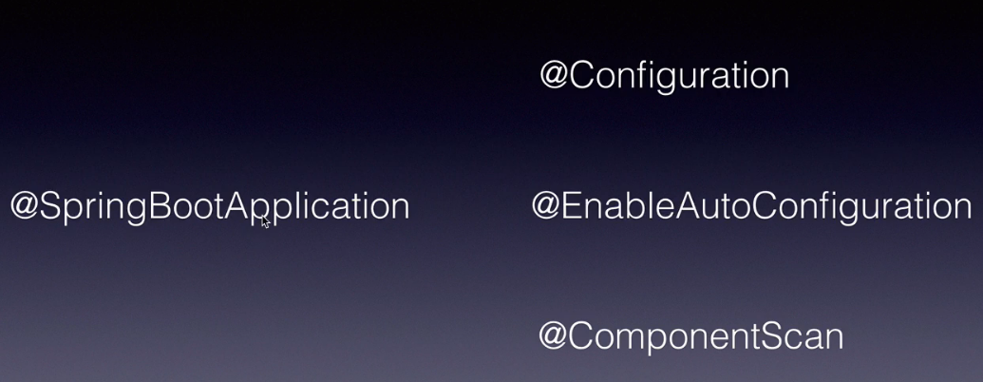

There are many Spring boot starters

Spring boot comes with embedded tomcat server , In spring boot no need of configuring dispatcher servlet and viewresolver for customizing we can use application.properties file.

Note : Artifact is our project name

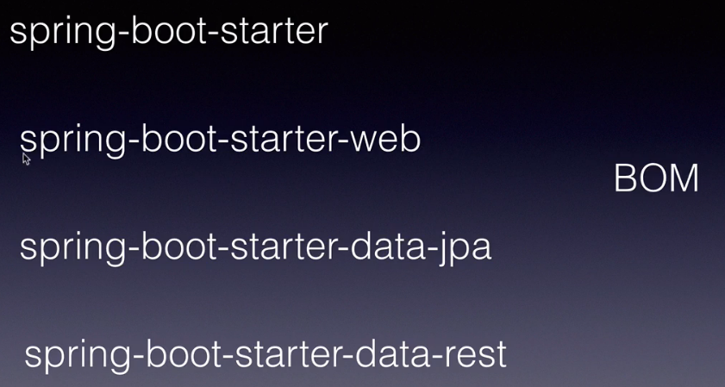

## How does spring boot works

# Spring JPA

# Restful Web Services

Patch http method is used for partial updates

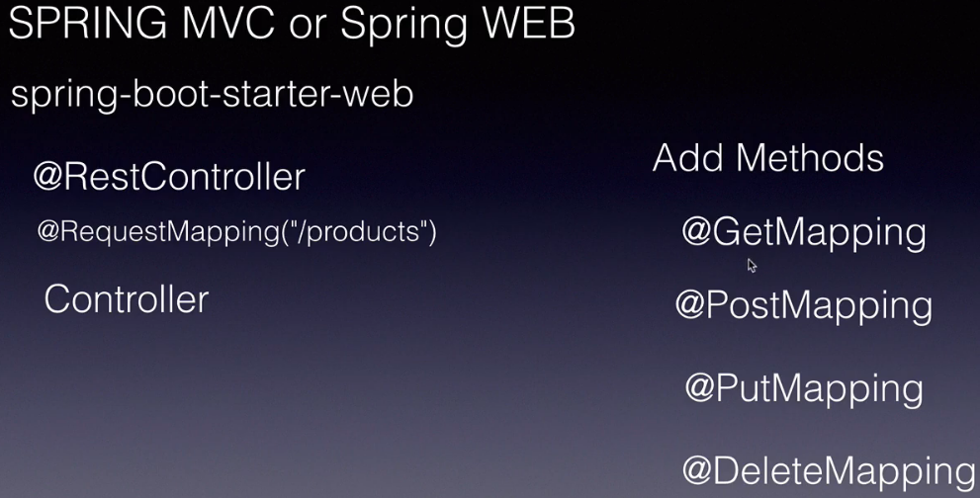 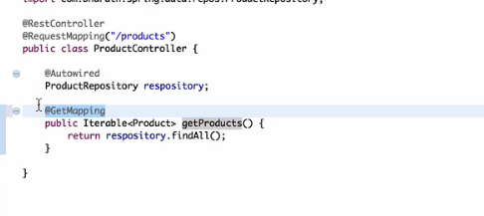it will automatically convert data into json on request

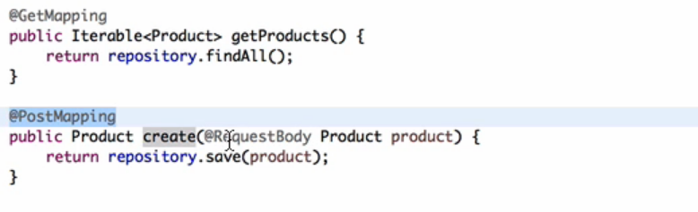

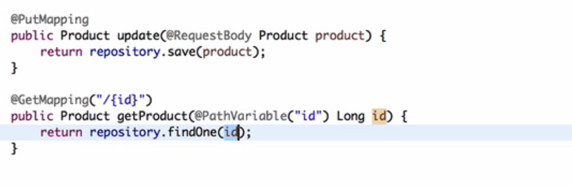

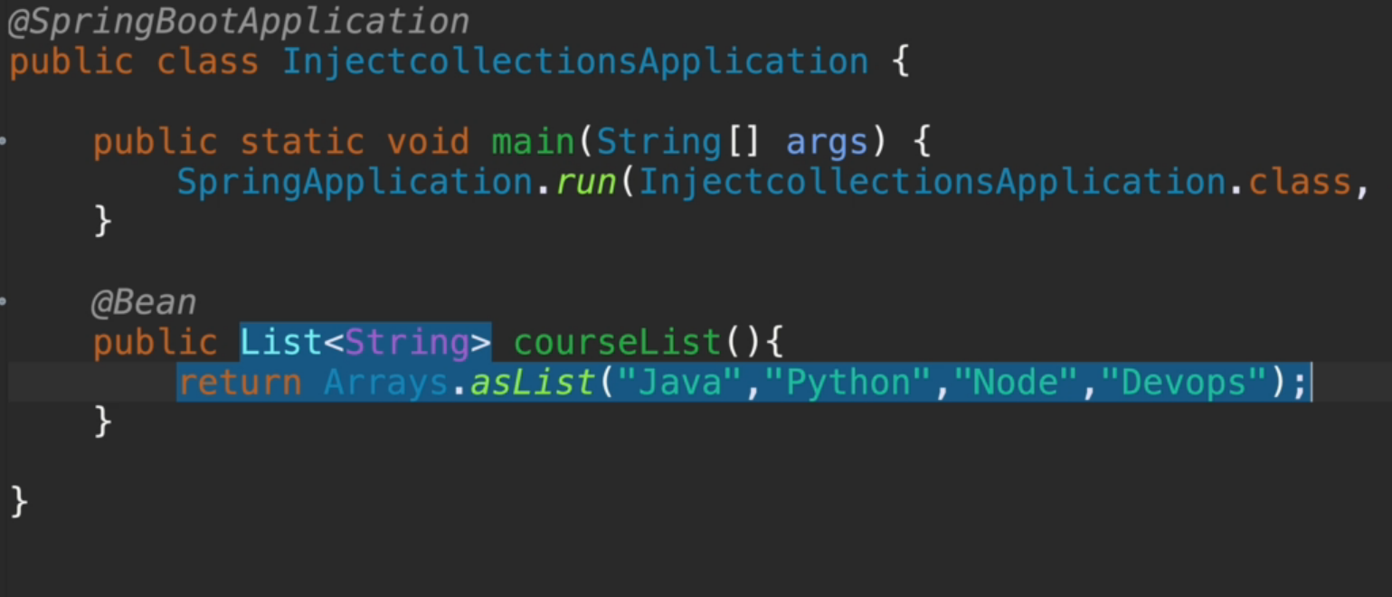

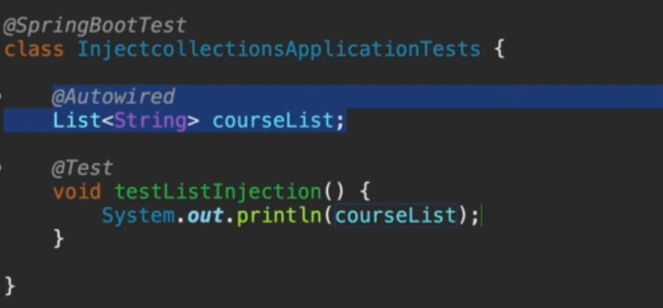

Note : Spring main class should be in parent package

# Java Servlet

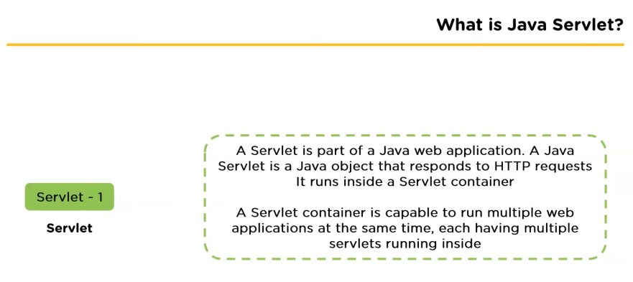

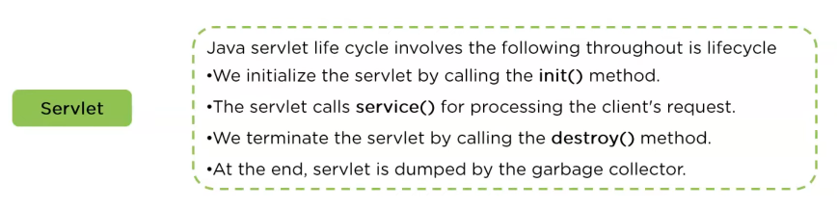

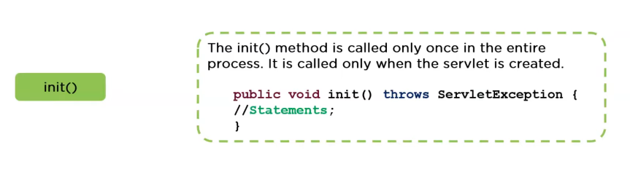

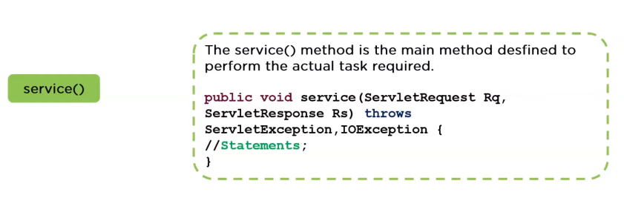

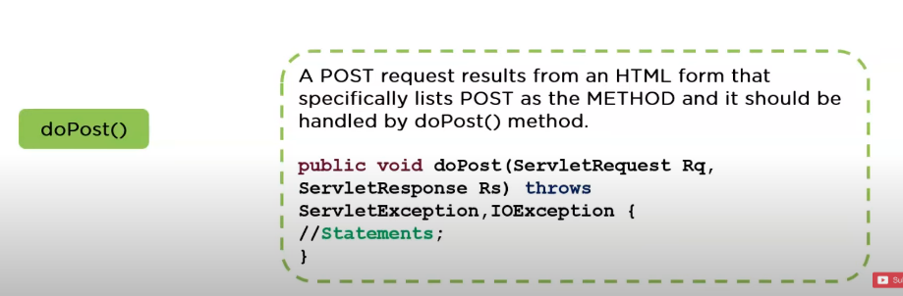

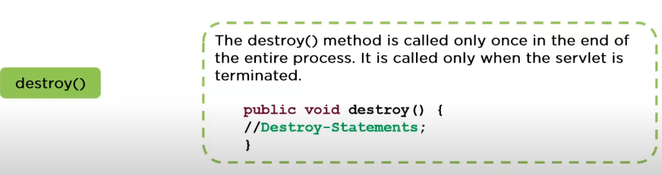

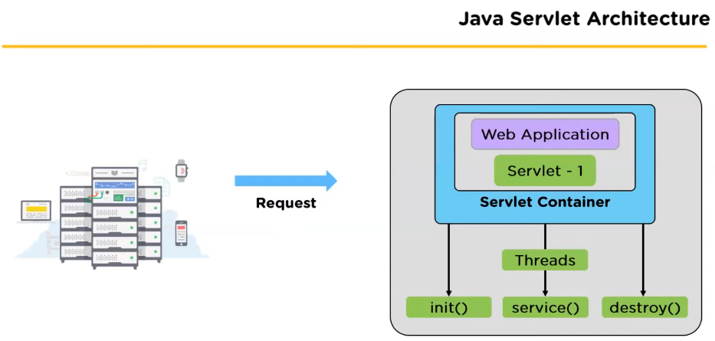

## Life Cycle of Servlet

## Architecture of Servlet

## Pros and cons

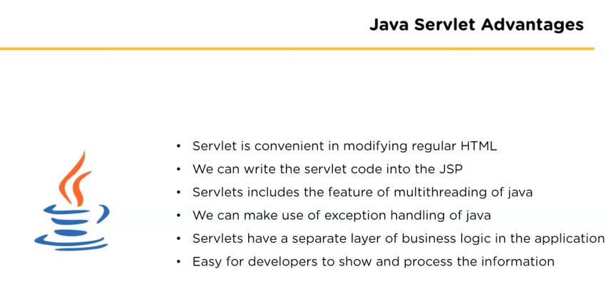

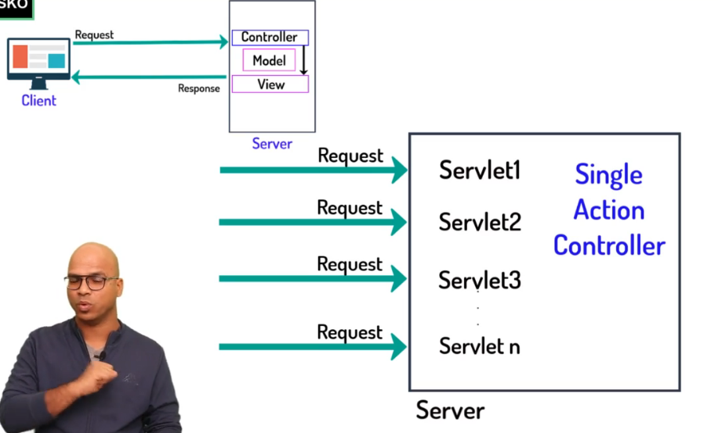

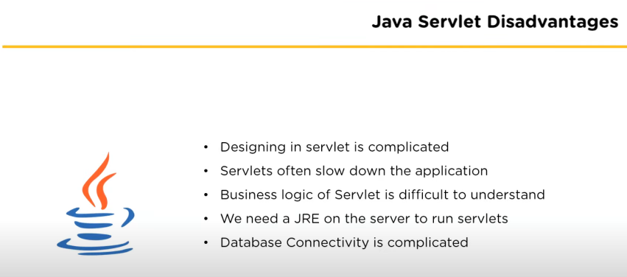

# Spring Core Interview Questions

**Q1. What do you understand by the terms Dependency Inversion Principle (DIP), Dependency Injection (DI) and Inversion of Control (IoC) container?**

A1. The differences are very subtle and can be hard to understand. Hence, explained via code samples.

1) Dependency Inversion Principle (DIP):  The idea of DIP is that higher layers of your application should not directly depend on lower layers. DIP is the principle that guides us towards DI pattern.

2) Dependency Injection (DI): is a design pattern where instead of having your objects create a dependency or asking a factory object to make one for you, you pass the needed dependencies into the constructor or via setters from outside the class. This is achieved by defining the dependencies as interfaces, and then injecting in a concrete class implementing that interface via a constructor (i.e. constructor injection) or a setter method (i.e. setter injection). Dependency Injection is a design pattern that allows us to write loosely coupled code for better maintainability,

3) Inversion of Control (IoC): is a software design principle where the framework controls the program flow. Spring framework, Guice, etc are IoC containers that implement the IoC principle.

**Q2. What are you “Inverting” in IoC?**

A2. Flow of control is “inverted” by dependency injection because you are effectively delegating dependencies to some external system .

**Q3. What are the different implementation patterns of IoC principle?**

A3. The two implementation patterns of the IoC design principles are

Dependency Injection (DI) pattern: A class is given its dependencies from outside like Spring IoC or JEE 7+ container. It neither knows, nor cares where the dependencies are coming from.

Service Locator (SL) pattern: A class is still responsible for creating its dependencies. It just uses the service locator to do it.

**Q4. When will you favor DI type “Constructor Injection” over “Setter Injection”?**

A4. Using constructor injection allows you to hide immutable fields from users of your class. Immutable classes don’t declare setter methods. This also enforces that you have the valid objects at the construction time. It also prompts you to rethink about your design when you have too many constructor parameters.

**Q5. When will you favor DI type “Setter Injection” over “Constructor Injection”?**

A5. In some scenarios, the constructors may get a lot of parameters, which force you to create a lot of overloaded constructors for every way the object might be created. In these scenarios setter injection can be favored over constructor injection, but having too many constructor parameters may be an indication of a bad design.

**Q6. Can you describe the bean life cycle?**

<https://reflectoring.io/spring-bean-lifecycle/>

<https://www.upgrad.com/blog/spring-bean-life-cycle-explained/>

A6. A Spring Bean represents a POJO (Plain Old Java Object) performing useful operation(s). All Spring Beans reside within a Spring IoC Container. The Spring Framework hides most of the complex infrastructure and the communication that happens between the Spring Container and the Spring Beans.

Spring Bean life cycle means the construction and destruction of the beans and usually this is in relation to the construction and destruction of the Spring Context. Spring has three ways of calling your code during initialization and shut down.

1. Programmatically, usually called ‘interface callbacks’: Spring calls your bean during the setup and tear down of the Spring Context, and your bean needs to implement InitializingBean or DisposableBean. Spring 3.0 has the Lifecycle interface with start/stop lifecycle control methods. The typical use case for this is to control asynchronous processing.

2. Declarative ‘method callbacks’ on a per bean basis: You use a method callback by adding a method to your bean, which you then reference in your XML config. When Spring reads the config it figures out that there’s a bean of type “A” with a method that it needs to call on startup and another it needs to call on shutdown.

3. Declarative ‘method callbacks’ to all beans.

**Initialization:**

Step 1: The spring container finds the bean’s definition from the XML file or annotations (like @Configuration) and instantiates the bean.

Step 2: Using the dependency injection, spring populates all of the bean properties as specified in the bean definition.

Step 3: If the bean implements the BeanNameAware interface, the factory calls “setBeanName()” passing the bean’s ID.

Step 4: If the bean implements the BeanFactoryAware interface, the factory calls “setBeanFactory()”, passing an instance of itself.

Step 5: If the bean implements the ApplicationContextFactoryAware interface, the container calls “bean.setApplicationContext(container)”.

Step 6: If there are any BeanPostProcessors associated with the bean, their “postProcessBeforeInitialization()” method will be called.

Step 7a: If the bean implements InitializingBean interface, “bean.afterPropertiesSet()” method will be invoked.

Step 7b: If the bean declares custom init method, the container calls custom init method of that bean

Step 8: If there are any BeanPostProcessors associated with the bean, their “postProcessAfterInitialization()” method will be called.

Step 9: Bean is now ready for use.

**shutdown:**

Step 1: If the bean implements DisposableBean interface, container calls the “bean.destroy()”.

Step 2: If the bean declares custom destroy method, container calls custom destroy method of bean.

**Q7. Does Spring dependency injection happen during compile time or runtime?**

A7. Runtime during the creation of an object.

**Q8. What is the difference between prototype scope and singleton scope? Which one is the default?**

A8. Singleton means single bean instance per IoC container, and prototype means any number of object instances per IoC container. The default scope is “singleton”.

**Q9. When will you use singleton scope? When will you use prototype scope?**

A9. Singleton scope is used for stateless object use. For example, injectiong a DAO (i.e. Data Access Object) into a service object. DAOs don’t need to maintain conversation state.

**For example:**

Prototype is useful when your objects maintain state in a multi-threaded environment. Each thread needs to use its own object and cannot share the single object. For example, you might have a RESTFul web service client making multi-threaded calls to Web services. The REST easy client APIs like RESTEasy uses the Apache Connection manager which is not thread safe and each thread should use its own client. Hence, you need to use the prototype scope.

**Q10. What happens if you inject a prototype scoped bean into a singleton scoped bean?**

A10. A new prototype scoped bean will be injected into a singleton scoped bean once at runtime, and the same prototype bean will be used by the singleton bean.

**Q11. What are the scopes defined in Web Application context?**

A11. Following scopes are only valid in the context of a web-aware Spring ApplicationContext

Request Scope is for a single bean definition to the lifecycle of a single HTTP request. In other words each and every HTTP request will have its own instance of a bean created off the back of a single bean definition.

Session Scope is for a single bean definition to the lifecycle of a HTTP Session.

Global Session Scope is for a single bean definition to the lifecycle of a global HTTP Session. Typically only valid when used in a Portlet context.